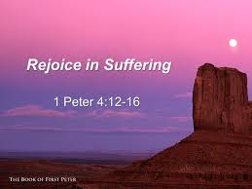
Getting More from the Message – 1 Peter 4:12-19
Community Group Questions – Week of February 28, 2016
Getting Started: Read this week’s passage out loud & pray the Holy Spirit will help you understand.
Ice Breaker: Can you tell us about someone who fell away from the faith because of suffering?
_____________________________________________________________________
- Why do many Christians get so confused when trials come upon them? (Do we default to grace?)
______________________________________________________________________________________________________________________________________
- Why do you think the Bible tells us so often to “rejoice”? (Do you have a rejoicing verse you love?) ______________________________________________________________________________________________________________________________________
- CS Lewis said that the Lord “shouts in our pains: it is His megaphone to rouse a deaf world.” Do you agree? Why or why not?
______________________________________________________________________________________________________________________________________
- What are some reasons that many people like Christians so much?
______________________________________________________________________________________________________________________________________
- How can trials and suffering show us those who are true believers and those who are not?
______________________________________________________________________________________________________________________________________
- How is it possible that the conviction of sin and repentance can produce joy in our souls?
______________________________________________________________________________________________________________________________________
- What does it mean to “commit our soul to the Lord in doing good”? (see verse 19)
______________________________________________________________________________________________________________________________________
- Can you tell us something that really encouraged you from this week’s Bible passage?
______________________________________________________________________________________________________________________________________
- Can you tell us something that really challenged you from this week’s Bible passage?
______________________________________________________________________________________________________________________________________
- How can we pray for you specifically regarding what we learned this week? ___________________________________________________________________

