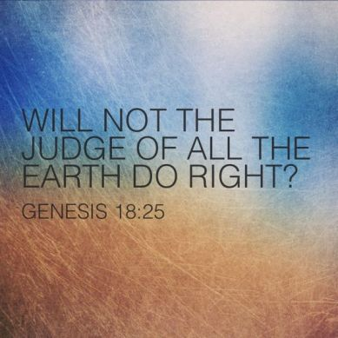
Getting More from the Message – Genesis 18:16-33
Community Group Questions – Week of January 24, 2021
Getting Started: Read this week’s passage out loud & pray the Holy Spirit will help you understand.

Ice Breaker: What are some of the emotions people are experiencing during this time in history?
_____________________________________________________________________
- What are some ways you think God wants to build and strengthen our faith during this time?
______________________________________________________________________________________________________________________________________
- Statistically the faith of many Christians is weakening right now. Why do you think that is? (How can belonging to our group and consistently attending the group help strengthen you?) ______________________________________________________________________________________________________________________________________
- What does it mean when we say, “God is creating a new and different people?”
______________________________________________________________________________________________________________________________________
- Why are we often reluctant to get involved in the lives of other people?
______________________________________________________________________________________________________________________________________
- We tend to “say our prayers” while Abraham spoke with God. What is the difference?
______________________________________________________________________________________________________________________________________
- If you are a follower of Jesus, why is it important you realize your potential influence in this world? ______________________________________________________________________________________________________________________________________
- What are some ways we (as individuals or as a group) can show compassion to people and share the Good News with them at the same time?
______________________________________________________________________________________________________________________________________
- Do you believe our corner of the world needs you and our church? Why or why not?
___________________________________________________________________
- Was there anything you wanted to ask or say to the group this week?
___________________________________________________________________
- Was there anything specific you think God wanted you to take away or change from this passage?
___________________________________________________________________
- How can we pray for you in regards to what we studied this week? Other prayer requests are fine, but we are also looking for a specific prayer request for you in regards to this week’s passage. ______________________________________________________________________________

