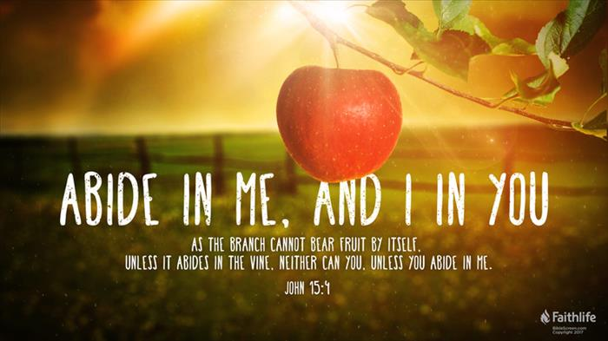
Getting More from the Message – John 15:4
Community Group Questions – Week of July 12, 2020
Getting Started: Read this week’s passage out loud & pray the Holy Spirit will help you understand.

Ice Breaker: Do you cook? If yes, do you prefer to follow recipes or adjust the ingredients as you go along? Please explain your answer, and if you have any funny stories, please share one.
_____________________________________________________________________
- Do you ever feel like something is missing from your Christian life? Please explain your answer.
______________________________________________________________________________________________________________________________________
- Can you explain the feeling of a burden being lifted off of you by Christ? ______________________________________________________________________________________________________________________________________
- Why do you think so many Christians feel living for Christ can be such a burden?
______________________________________________________________________________________________________________________________________
- What is the effect of “weariness” in the Christian life?
______________________________________________________________________________________________________________________________________
- How is a living, loving, and vibrant relationship with Jesus different than religion?
______________________________________________________________________________________________________________________________________
- How does “false teaching” lead so many peopl to fall away from the faith? ______________________________________________________________________________________________________________________________________
- As we study John 15, what changes are you hoping and praying the Lord will make in your life?
______________________________________________________________________________________________________________________________________
- Is there a specific person God is laying on your heart to watch or listen to these messages? Why do you think it is that person, and what are you going to do about it?
______________________________________________________________________________________________________________________________________
- Was there anything you wanted to ask or say to the group this week?
______________________________________________________________________________________________________________________________________
- Was there anything specific you think God wanted you to take away or change from this passage?
___________________________________________________________________
- How can we pray for you in regards to what we studied this week? Other prayer requests are fine, but we are also looking for a specific prayer request for you in regards to this week’s passage. ______________________________________________________________________________

