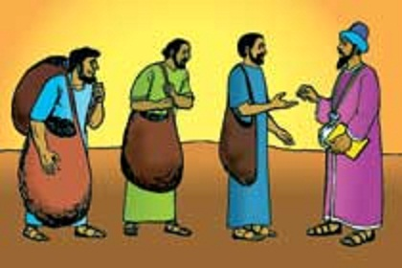
Getting More from the Message – Matthew 20:1-16
Community Group Questions – Week of February 17, 2019
Getting Started: Read this week’s passage out loud & pray the Holy Spirit will help you understand.

- Ice Breaker: Do you believe many people are just going through the motions with their faith and worship? Please explain.
_____________________________________________________________________
- In this parable, many people feel like God was being unfair. What do you think and why? ______________________________________________________________________________________________________________________________________
- Most people are offended when they hear “Good people don’t go to heaven - only forgiven people do.” What are some kind-hearted ways we can explain the difference to people?
______________________________________________________________________________________________________________________________________
- Why is it important to explain to people that Jesus came to us BEFORE we come to Him?
______________________________________________________________________________________________________________________________________
- Why do you think God considers grumbling and complaining to be such a serious sin? ______________________________________________________________________________________________________________________________________
- Why is comparison to others a hindrance in developing a strong Christian walk?
______________________________________________________________________________________________________________________________________
- Name three well-known sinners in history. If someone asked you if it was possible for them to receive the grace of God and go to Heaven, what would you say? How would you explain it? ______________________________________________________________________________________________________________________________________
- Do you feel that you have experienced stunning or shocking grace? Please explain your answer.
_____________________________________________________________________________________________________________________________________
- Was there anything you wanted to ask or say to the group this week?
___________________________________________________________________
- Was there anything specific you think God wanted you to take away or change from this passage?
___________________________________________________________________
- How can we pray for you in regards to what we studied this week? Other prayer requests are fine, but we are also looking for a specific prayer request for you in regards to this week’s passage. ______________________________________________________________________________

