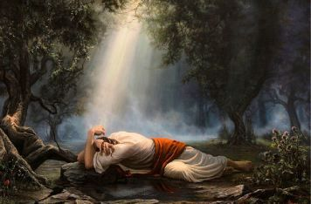
Getting More from the Message – Matthew 26:36-46
Community Group Questions – Week of October 13, 2017
Getting Started: Read this week’s passage out loud & pray the Holy Spirit will help you understand.

Ice Breaker: Have you ever been let down by someone before? How did that feel? Please explain.
_____________________________________________________________________
- What was your reaction to Jesus moving from cool, calm and collected to being so distraught?
______________________________________________________________________________________________________________________________________
- What struck you about the way Jesus prayed?
______________________________________________________________________________________________________________________________________
- It is easy for our group prayer times to be like the apostles – sleepy! Why do you thing that is?
______________________________________________________________________________________________________________________________________
- What did you think about the fact that coming to the Lord “sad” does not mean a lack of faith? ______________________________________________________________________________________________________________________________________
- Many people teach that if you have enough “faith,” you will get what you want from God. However, Jesus did not get what He asked for. How do you reconcile these two things?
______________________________________________________________________________________________________________________________________
- Can you give us an example from your life where your spirit is willing, but your flesh is weak? ______________________________________________________________________________________________________________________________________
- Why is it better to trust God even when His will seems to conflict with our desires?
______________________________________________________________________________________________________________________________________
- Was there anything you found particularly interesting in this passage that you want to share with the group? Do you have any questions for the group?
______________________________________________________________________________________________________________________________________
- Was there anything specific you think God wanted you to take away or change from this passage?
___________________________________________________________________
- How can we pray for you in regards to what we studied this week? Other prayer requests are fine, but we are also looking for a specific prayer request for you in regards to this week’s passage. ______________________________________________________________________________

