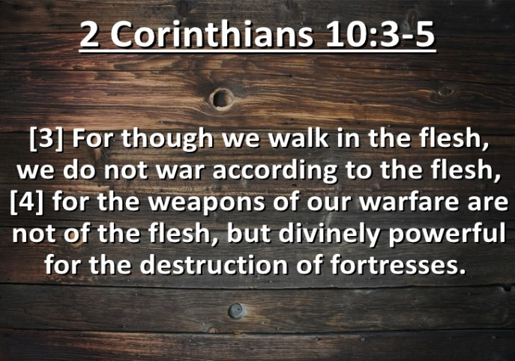
Getting More from the Message – 2 Corinthians 10:1-6
Community Group Questions – Week of October 23, 2016
Getting Started: Read this week’s passage out loud & pray the Holy Spirit will help you understand.

Ice Breaker: What are some battles that our country finds itself in right now?
_____________________________________________________________________
- What are some American cultural values that are contrary to the Word of God that has entered our churches in America? (As Christians how should we react?)
______________________________________________________________________________________________________________________________________
- How can we keep from getting drawn in to the lack of morality in American culture? ______________________________________________________________________________________________________________________________________
- What do we mean when we say that “the church” carries the authority of the Word of God?
______________________________________________________________________________________________________________________________________
- If there is a “stronghold” of incorrect belief in our lives, should we “let go and let God” or should we “do something?” Please explain. (Have any of your incorrect or false beliefs changed since you started studying the Bible?)
______________________________________________________________________________________________________________________________________
- Can you try to explain the tension between God’s sovereignty and our responsibility?
______________________________________________________________________________________________________________________________________
- If Jesus won our victory at the cross, why are there so many “doom and gloom” Christians? ______________________________________________________________________________________________________________________________________
- If the Holy Spirit is conforming us into the image of Christ why do so many Christian push back against the Bible teaching that how we live matters?
______________________________________________________________________________________________________________________________________
- What does it mean to be transformed by the power of God?
______________________________________________________________________________________________________________________________________
- How can we pray for you in regards to what we studied this week? ___________________________________________________________________

