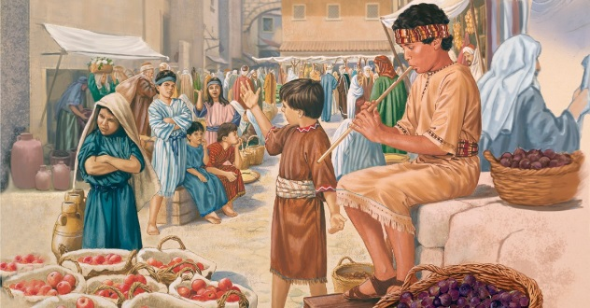
Getting More from the Message – Matthew 11:16-24
Community Group Questions – Week of February 18, 2018
Getting Started: Read this week’s passage out loud & pray the Holy Spirit will help you understand.

Ice Breaker: Some people say Jesus only had nice things to say to make people happy. How would you answer them after hearing Jesus speak this week? _____________________________________________________________________
- Why do you think we as humans are so hard to please, even for God? ______________________________________________________________________________________________________________________________________
- Do you find most people’s opinions about God match up with the scriptures or not? Please explain your answer. _____________________________________________________________________________________________________________________________________
- Why is self-centeredness and discontentment dangerous for your faith? ______________________________________________________________________________________________________________________________________
- Is it okay not to follow the message of the Bible just because you don’t like the way the message was delivered? Please explain your answer. ______________________________________________________________________________________________________________________________________
- What privileges do we have as American Christians that other people in the world do not have? Why do you think Jesus said we will be held more accountable for having those privileges? ______________________________________________________________________________________________________________________________________
- Our church’s theme is, “Helping people grow into committed followers of Jesus Christ.” How does teaching through the Bible verse by verse and not avoiding the hard passages help that?
_____________________________________________________________________________________________________________________________________
- Some people might say this week’s passage was scary. How would you answer them?
___________________________________________________________________
- Next week, we will hear one of the grand invitations of the Bible. Is there anyone we can pray for that you want to invite or drive to church? ___________________________________________________________________
- Was there anything specific you think God wanted you to take away from this week’s passage?
___________________________________________________________________
- How can we pray for you in regards to what we studied this week? Other prayer requests are fine, but we are also looking for a specific prayer request for you in regards to this week’s passage. ___________________________________________________________________

