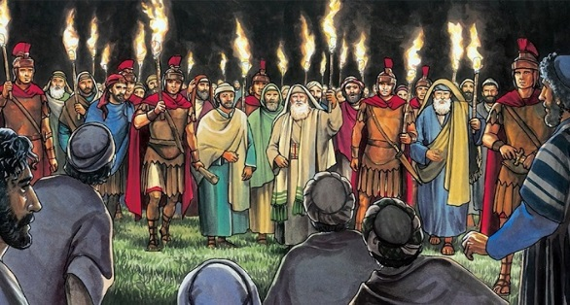
Getting More from the Message – Matthew 26:47-56
Community Group Questions – Week of October 27, 2019
Getting Started: Read this week’s passage out loud & pray the Holy Spirit will help you understand.

Ice Breaker: Have you ever been betrayed by someone you loved? What did (or does) that feel like?
_____________________________________________________________________
- Many people who say they are Christians do not consider the cross as important as being a “good person.” Why do you think that is? What is a good person?
______________________________________________________________________________________________________________________________________
- How do you feel about Judas, the “betrayer” also being “one of the twelve”? What are your thoughts about Judas betraying Jesus with a kiss? Do you think God wanted these things to shock us? Why or why not? ______________________________________________________________________________________________________________________________________
- What does a false disciple look like? Is it wrong for us to kindly ask people who say they are Christians about their faith? ______________________________________________________________________________________________________________________________________
- Like Jesus, many in the Bible are busy and under stress, yet still serve others. Why do you think so many American Christians use that as a reason not to serve? Is it possibly an excuse?
______________________________________________________________________________________________________________________________________
- In what ways was Jesus in control of this seemingly out-of-control situation? Does that give you confidence that He is in control when you are in a seemingly out-of-control situation? ______________________________________________________________________________________________________________________________________
- Is it easy for us to default back to following the Kingdom of Man instead of the Kingdom of God?
______________________________________________________________________________________________________________________________________
- How easy and how common is it for Christians to mix those two Kingdoms together?
______________________________________________________________________________________________________________________________________
- Was there anything you wanted to ask or say to the group this week?
___________________________________________________________________
- Was there anything specific you think God wanted you to take away or change from this passage?
___________________________________________________________________
- How can we pray for you in regards to what we studied this week? Other prayer requests are fine, but we are also looking for a specific prayer request for you in regards to this week’s passage. ______________________________________________________________________________

