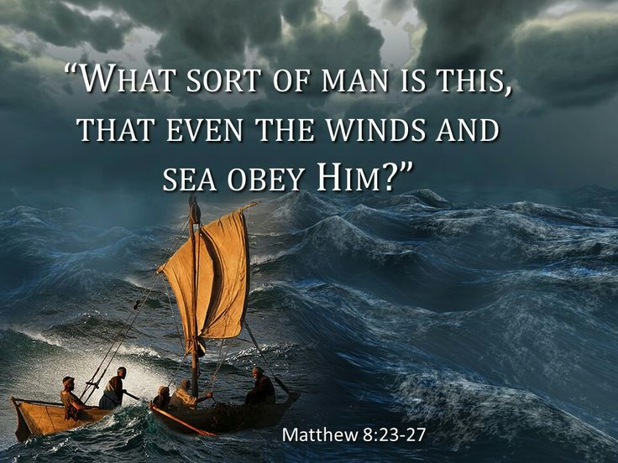
Getting More from the Message – Matthew 8:23-27
Community Group Questions – Week of October 22, 2017
Getting Started: Read this week’s passage out loud & pray the Holy Spirit will help you understand.

Ice Breaker: If you took a poll in your neighborhood and asked people to explain the identity of Jesus, what kinds of things would you expect to hear? ____________________________________________________________________
- By getting in the boat, the disciples were obeying and following Jesus, but the storm still came to them. In those times the Lord calls us to trust in Him and His plan, how do we (you) do that? ___________________________________________________________________
- Has the Lord ever put you in (or allowed) a “storm season” in your life that was completely out of your control? Can you describe it and the effect on your faith?
______________________________________________________________________________________________________________________________________
- The four Gospel writers usually record the events of Jesus’ life with some variations in their accounts. Skeptics say that proves they are false testimonies. How would you answer them? ______________________________________________________________________________________________________________________________________
- How could Jesus sleep through such a big storm? What woke Jesus up? ______________________________________________________________________________________________________________________________________
- The apostles were terrified when the storm came. What is the effect of fear on faith? Can you explain how fear has effected your faith? ______________________________________________________________________________________________________________________________________
- Write out Hebrews 4:15 on the back of this page. What do you think it means, and how can you apply it to your life? ______________________________________________________________________________________________________________________________________
- Why is it important for a Christian to remember that the Lord is with them wherever they go? ___________________________________________________________________
- If a friend, family member or co-worker asked you what you did on Sunday and you wanted to answer with what you learned, how would you answer them in one sentence? ___________________________________________________________________
- Was there anything specific you think God wanted you to take away from this week’s passage?
___________________________________________________________________
- How can we pray for you in regards to what we studied this week? Other prayer requests are fine, but we are also looking for a specific prayer request for you in regards to this week’s passage. ___________________________________________________________________

