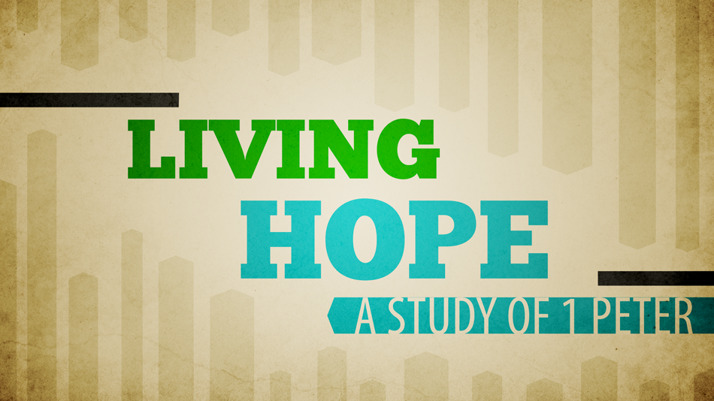
Getting More from the Message – 1 Peter 1:22-2:3
Community Group Questions – Week of November 8, 2015
Getting Started: Read 1 Peter 1:22-2:3 and pray that the Holy Spirit will give you understanding.
Ice Breaker: Do you have any bad, funny, or odd church experiences you can share with us?
_____________________________________________________________________
- Why does Jesus Christ desire (or require) us to have love for the other people in the church?
___________________________________________________________________
- Can you think of some practical ways (besides just saying “We will pray!” ) that we can all extend love to others in the church? How do you think Jesus wants you to help others? ______________________________________________________________________________________________________________________________________
- What is it that often hinders you from getting involved in the lives of others? (Is it an excuse?)
______________________________________________________________________________________________________________________________________
- Read John 13:35. Before you were a Christian how were you influenced by the love of Christians for each other? Why is the priority of love so important in our church?
______________________________________________________________________________________________________________________________________
- Why do so many people seem to like impersonal churches? Is that view Biblical? Why or why not?
___________________________________________________________________
- Most Christians attend church less often than they used to. Do you think there is any connection between church attendance and your love for Christ and His church? Please explain your answer.
______________________________________________________________________________________________________________________________________
- How does the Holy Spirit use conflict and sinful humanity to grow us in our faith?______________
___________________________________________________________________
- Why is it so important that we desire the Word of God instead of the latest “fads”? What (if any) harm have you seen from Christians neglecting, adding, to or watering down the Word of God?
______________________________________________________________________________________________________________________________________
- How has the Lord, through the Word of God, given you a new past, present, and future?
___________________________________________________________________
- Why is it important you are hungry for the Word of God? With whom can you share your hunger?
___________________________________________________________________
- How can we pray for you in regards to the priority of love for the church or the Word of God?
___________________________________________________________________

