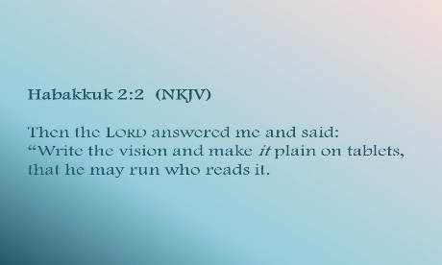
Getting More from the Message – Habakkuk 2:1-5
Community Group Questions – Week of May 10, 2020
Getting Started: Read this week’s passage out loud & pray the Holy Spirit will help you understand.

Ice Breaker: Would you say most people feel like their life is on hold right now?
_____________________________________________________________________
- What are some things we can do to reach out to people in these difficult times?
______________________________________________________________________________________________________________________________________
- What does it mean to “glance at God & gaze at Goliath”? Do you tend to do that? Please explain. ______________________________________________________________________________________________________________________________________
- What are some ways you can position yourself to hear from the Lord?
______________________________________________________________________________________________________________________________________
- Habakkuk wanted to hear from the Lord before He spoke to people. Do you think that is important? Why or why not?
______________________________________________________________________________________________________________________________________
- Read Proverbs 3:5-6 out loud. How would you apply that to yourself?
______________________________________________________________________________________________________________________________________
- Why do you think we should try to explain the Bible simply to people? ______________________________________________________________________________________________________________________________________
- What does it mean that we shall live by our faith?
______________________________________________________________________________________________________________________________________
- Next week, we will talk about waiting on God. What has that been like for you?
______________________________________________________________________________________________________________________________________
- Was there anything you wanted to ask or say to the group this week?
______________________________________________________________________________________________________________________________________
- Was there anything specific you think God wanted you to take away or change from this passage?
___________________________________________________________________
- How can we pray for you in regards to what we studied this week? Other prayer requests are fine, but we are also looking for a specific prayer request for you in regards to this week’s passage. ______________________________________________________________________________

