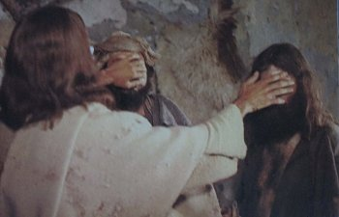
Getting More from the Message – Matthew 20:29-34
Community Group Questions – Week of March 3rd, 2019
Getting Started: Read this week’s passage out loud & pray the Holy Spirit will help you understand.

Ice Breaker: What are some things that are right in front of people that they are often blind to?
_____________________________________________________________________
- Jesus loved and served others even when facing the cross. How can the selfless love of Jesus motivate and empower us to love and serve others? (How does it defeat selfishness?) ___________________________________________________________________
- In this passage, the crowd seems to have Jesus wrong. What are some of the dangers of following the crowd? Is a church always good simply because it is large? (See Luke 6:26.)
______________________________________________________________________________________________________________________________________
- How is it possible that we see Jesus by hearing (or reading) about Him in the Word of God? Do you believe that many people have Jesus wrong, because they do not meet Him in the Word?
______________________________________________________________________________________________________________________________________
- What does it mean to have our spiritual eyes opened? ___________________________________________________________________
- When speaking to people about Christ, how important is it to pray that the Holy Spirit opens their eyes? (Should you pray while you are speaking to them?)
___________________________________________________________________
- What are some ways people who say they believe can actually be a barrier to the faith of others? ___________________________________________________________________
- Why are religious people so hard to reach with the truth of the Gospel? What have you seen happen when someone moves from ritual religion to a personal relationship with Jesus Christ?
______________________________________________________________________________________________________________________________________
- What are the current obstacles or barriers that you feel are hindering your faith these days? What touch do you need from Jesus today? ___________________________________________________________________
- Do you think most people ask for what they really need from Jesus, or just what they want now?
___________________________________________________________________
- How is it that true faith leads to following Jesus? Please explain.
___________________________________________________________________
- Was there anything specific you think God wanted you to take away or change from this passage?
___________________________________________________________________
- How can we pray for you in regards to what we studied this week? Other prayer requests are fine, but we are also looking for a specific prayer request for you in regards to this week’s passage. ______________________________________________________________________________

