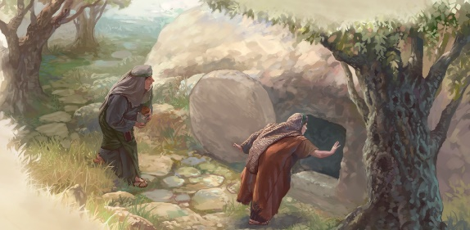
Getting More from the Message – Matthew 28:1-10
Community Group Questions – Week of March 1, 2020

Getting Started: Read this week’s passage out loud & pray the Holy Spirit will help you understand.

Ice Breaker: What are some of the things you think people associate with Easter?
_____________________________________________________________________
- Why do you think the Bible writers are so “matter of fact” about the miraculous events in the Bible? ______________________________________________________________________________________________________________________________________
- Why is a physical, bodily resurrection of Jesus critical to the validity of the Christian faith? Was Jesus’ resurrection body the same as His pre-crucifixion body? (Read 1 Corinthians 15 for help.) ___________________________________________________________________
- Why do you think some people are more enamored with angels than with Jesus? What are the roles of angels? ______________________________________________________________________________________________________________________________________
- Have you experienced the “grace of failure”? What happened, and how did that help you to grow spiritually? ___________________________________________________________________
___________________________________________________________________
- Why is the evidence for the resurrection important? Can you name a few things that make the case for the resurrection? ______________________________________________________________________________________________________________________________________
- How did the Lord use the apostles’ failures to turn them into bold servants for the Kingdom of God? What does the fact that God uses “ordinary” people to grow His Kingdom mean to you? ______________________________________________________________________________________________________________________________________
- Next week, we celebrate our 15th anniversary as a church. How long have you been at Calvary, and what have you seen the Lord do? What are you praying for the Lord to do in and through you, and in and through our church, in the next 5 years? ______________________________________________________________________________________________________________________________________
- Please write your own question for the group to answer: ______________________________________________________________________________________________________________________________________
- Was there anything specific you think God wanted you to take away from this passage?
___________________________________________________________________
- How can we pray for you in regards to what we studied this week? Other prayer requests are fine, but we are also looking for a specific prayer request for you in regards to this week’s passage. ___________________________________________________________________

