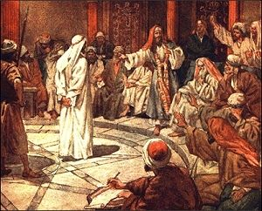
Getting More from the Message – Matthew 26:57-68
Community Group Questions – Week of November 3, 2019
Getting Started: Read this week’s passage out loud & pray the Holy Spirit will help you understand.

Ice Breaker: When speaking to people about Jesus, why is it important to hear what they have to say? (What are some of the more common things you have heard, and what did you think?)
_____________________________________________________________________
- Why do you think there are so many misinterpretations and/or misrepresentations of Jesus? What should we do when we hear people doing that? (Is it easy or difficult?- Please explain) ______________________________________________________________________________________________________________________________________
- Why doesn’t following Jesus at a distance work?
______________________________________________________________________________________________________________________________________
- Why does Jesus want His followers to be “all in”? What do you think “all in” means? Are there any changes you could make to be “all in”?
______________________________________________________________________________________________________________________________________
- Why do you think so many people’s minds are made up about Jesus, and they are unwilling to talk about Him? (Do you have any thoughts or ideas on getting the conversation started?) ______________________________________________________________________________________________________________________________________
- How do people judge God? How is it that we seem to take credit for what we do and often blame God for what goes wrong?
______________________________________________________________________________________________________________________________________
- Read Romans 12:1-2 out loud. What are some ways we can worship God? What are some ways you think God may want you to worship Him more? As a church, how do you think we can do a better job at worshipping Jesus together? ______________________________________________________________________________________________________________________________________
- Was there anything you wanted to ask or say to the group this week?
______________________________________________________________________________________________________________________________________
- Was there anything specific you think God wanted you to take away or change from this passage?
___________________________________________________________________
- How can we pray for you in regards to what we studied this week? Other prayer requests are fine, but we are also looking for a specific prayer request for you in regards to this week’s passage. ______________________________________________________________________________

