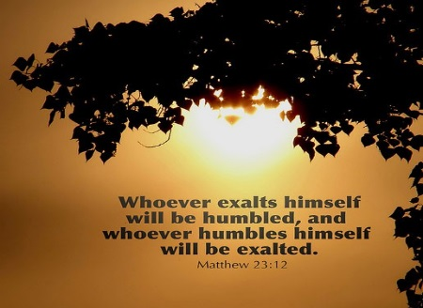
Getting More from the Message – Matthew 23:1-12 Community Group Questions – Week of June 2, 2019
Getting Started: Read this week’s passage out loud & pray the Holy Spirit will help you understand.

Ice Breaker: What are your thoughts on the leadership situation in our country right now, and what should Christians do?
_____________________________________________________________________
- What is the difference between a “religious burden” and a “house rule”? ______________________________________________________________________________________________________________________________________
- Jesus was often confrontational when it concerned false teaching. Do you believe Christians often say little or nothing about false teaching? If yes, why?
______________________________________________________________________________________________________________________________________
- Why do you think so many people blindly follow bad leaders? Why do you think some people won’t follow any kind of a leader?
______________________________________________________________________________________________________________________________________
- Did you grow up in a system where the religious leaders were highly esteemed? If yes, what was that like? Do you know any people who are afraid to leave such systems? If yes, why?
______________________________________________________________________________________________________________________________________
- Why do you think some people serve to be seen? (What are the signs of that?) ______________________________________________________________________________________________________________________________________
- Many people feel they need a “title” before they can lead, while others disagree. What are your thoughts?
______________________________________________________________________________________________________________________________________
- What are some ways some Christians commonly take the eyes of people off Jesus?
______________________________________________________________________________________________________________________________________
- This is the last night of our group. We try and re-unite on Wednesdays in July and August for “Summer Suppers.” Is that something you would like to do, or do you anticipate being too busy?
___________________________________________________________________
- Was there anything specific you think God wanted you to take away or change from this passage?
___________________________________________________________________
- How can we pray for you in regards to what we studied this week? Other prayer requests are fine, but we are also looking for a specific prayer request for you in regards to this week’s passage. ______________________________________________________________________________

