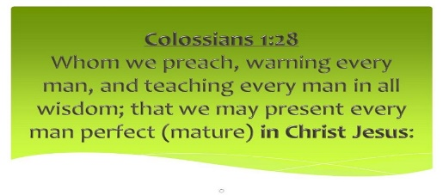
Getting More from the Message – Colossians 1:28
Community Group Questions – Week of March 8, 2020

Getting Started: Read this week’s passage out loud & pray the Holy Spirit will help you understand.

Ice Breaker: Do you think most people who “claim faith” want to be mature in their faith? Please explain your answer.
_____________________________________________________________________
- Were you challenged this week in your own personal Christian maturity? If yes, how and in what areas would you say you need to grow? Do you have any practical thoughts on how to grow in those areas? ______________________________________________________________________________________________________________________________________
- This week’s passage suggested we all have a responsibility to help others in our group and in our church grow in maturity. How can we practically help one another with that? ___________________________________________________________________
- Why is it necessary a church preaches Christ first and foremost? What are some possible pitfalls of a church following the trends of the culture instead of the Word of God? (Can that be subtle?) ______________________________________________________________________________________________________________________________________
- Can you explain what the Apostle Paul means when he says, “Christ in you, the hope of glory”? ___________________________________________________________________
___________________________________________________________________
- Why is our motivation important in the Christian life? What are good motivations? What are unhealthy and even sinful motivations? What motivates you to live for Christ? ______________________________________________________________________________________________________________________________________
- Many people depend almost solely on their religious leaders for their faith. Do you think that is right? Please explain. Is it possible to be too over- dependent on our leaders? Please explain. ______________________________________________________________________________________________________________________________________
- Many Christians are intimidated by those who know more about the faith than they do, yet the Apostle Paul pointed out three times in verse 28 that God’s vision for maturity was for “every man” (and woman) . What is your reaction to that? ______________________________________________________________________________________________________________________________________
- Please write your own question for the group to answer: ______________________________________________________________________________________________________________________________________
- Was there anything specific you think God wanted you to take away from this passage?
___________________________________________________________________
- How can we pray for you in regards to what we studied this week? Other prayer requests are fine, but we are also looking for a specific prayer request for you in regards to this week’s passage. ___________________________________________________________________

