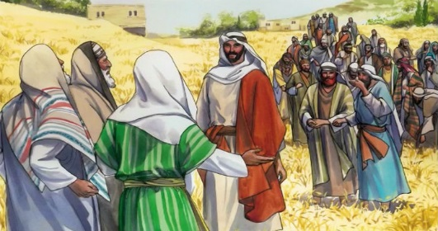
Getting More from the Message – Matthew 12:1-14
Community Group Questions – Week of March 4, 2018
Getting Started: Read this week’s passage out loud & pray the Holy Spirit will help you understand.

Ice Breaker: Did you ever talk to someone about Jesus whose understanding was almost totally uninformed opinion? What was that like? How did you speak with them? _____________________________________________________________________
- Why do you think humans who say they believe the Bible are so prone to add to the Bible or subtract from the Bible? ______________________________________________________________________________________________________________________________________
- What would you say the “distinctives” of the Christian faith are? _____________________________________________________________________________________________________________________________________
- Do you think it is a good idea to set aside a day of worship? Please explain why or why not. ______________________________________________________________________________________________________________________________________
- Statistically, many Bible-believing Christians are attending church less often than before, and many have stopped going all together. Why do you think that is? How would you counsel a friend in one of those two groups? ______________________________________________________________________________________________________________________________________
- What is your reaction to God’s desire for mercy and kindness over religious ritual? Why do so many people seem to prefer religious ritual? ______________________________________________________________________________________________________________________________________
- Did you feel challenged by Jesus expressing His desire for our practical expressions of compassion towards others? Please explain. _____________________________________________________________________________________________________________________________________
- How is it possible that people could actually be angry that Jesus healed a man on the Sabbath? ___________________________________________________________________
- If a friend told you they were too far gone to be “restored” by Jesus, what would you tell them and how would you say it? (Would including the story of the cross of Christ be helpful?)
___________________________________________________________________
- Was there anything specific you think God wanted you to take away from this week’s passage?
___________________________________________________________________
- How can we pray for you in regards to what we studied this week? Other prayer requests are fine, but we are also looking for a specific prayer request for you in regards to this week’s passage. ___________________________________________________________________

