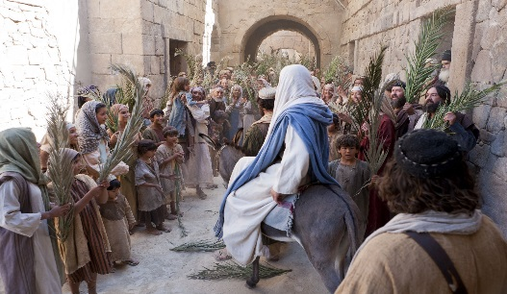
Getting More from the Message – Matthew 21:1-11
Community Group Questions – Week of March 10, 2019
Getting Started: Read this week’s passage out loud & pray the Holy Spirit will help you understand.

Ice Breaker: Why do you think many people look for leaders that will fix their problems instead of leaders that will lead them to something greater than they are or have now?
_____________________________________________________________________
- Why was Jesus’ fulfillment of Old Testament prophesies so important? What effect does the fulfillment of prophecy have on your faith? ______________________________________________________________________________________________________________________________________
- Why do you think Jesus took on the position or role of a servant so often?
______________________________________________________________________________________________________________________________________
- Did you ever celebrate or observe Palm Sunday as a child? What did you think it meant?
______________________________________________________________________________________________________________________________________
- Two disciples were sent for a donkey. Why is it important to be faithful in the little things the Lord asks us to do? (Do you get bored with those “little things”? Please explain.) ______________________________________________________________________________________________________________________________________
- Many people say Jesus was a “good teacher,” yet He also claimed to be God. Would that make Him a good teacher, a crazy man or perhaps something else? What do you think?
______________________________________________________________________________________________________________________________________
- Why do you think so many people miss the true identity of Jesus? Why do you think many people are unwilling to talk about it? How important is it that we can explain the identity of Jesus? ______________________________________________________________________________________________________________________________________
- Why is a King on a cross better than a King on a warhorse?
______________________________________________________________________________________________________________________________________
- Was there anything you wanted to ask or say to the group this week?
______________________________________________________________________________________________________________________________________
- Was there anything specific you think God wanted you to take away or change from this passage?
___________________________________________________________________
- How can we pray for you in regards to what we studied this week? Other prayer requests are fine, but we are also looking for a specific prayer request for you in regards to this week’s passage. ______________________________________________________________________________

