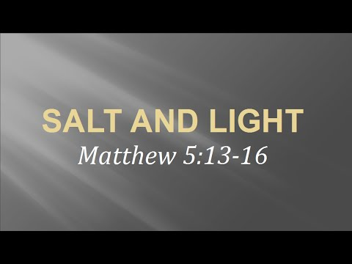
Getting More from the Message – Matthew 5:13-16
Community Group Questions – Week of March 12, 2017
Getting Started: Read this week’s passage out loud & pray the Holy Spirit will help you understand.

Ice Breaker: How do you think social media is changing our culture?
_____________________________________________________________________
- What are your thoughts on the different influences people have or have had on your faith? ______________________________________________________________________________________________________________________________________
- Can you tell us about the first person you met who had a positive Kingdom influence on you?
______________________________________________________________________________________________________________________________________
- What do you think being a “salty Christian” means?
______________________________________________________________________________________________________________________________________
- Christians are called the salt of the earth and the light of the world. Can you put into words what that means and how serious that is to you? ______________________________________________________________________________________________________________________________________
- Most Christians would say they want “Christ’s heart.” If that is true what should most Christians’ hearts be towards non-Christians and struggling Christians? ______________________________________________________________________________________________________________________________________
- What is a danger in only being focused on “my relationship with Jesus”?
______________________________________________________________________________________________________________________________________
- What are some ways Christians tend to be worldly and selfish? (What do you think about that?) ___________________________________________________________________
- What are some “good works” we can do to shine the light of Christ in our corner of the world? ___________________________________________________________________
- Was there anything specific you think God wanted you to take away from this passage?
___________________________________________________________________
- How can we pray for you in regards to what we studied this week? Other prayer requests are fine, but we are also looking for a specific prayer request for you in regards to this week’s passage. ___________________________________________________________________

