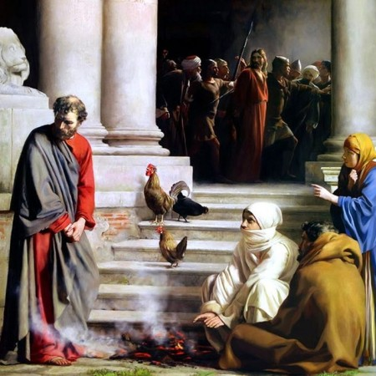
Getting More from the Message – Matthew 26:69-75

Community Group Questions – Week of November 10, 2019

Getting Started: Read this week’s passage out loud & pray the Holy Spirit will help you understand.

Ice Breaker: Why do you think many people write people off when they make a mistake?
_____________________________________________________________________

- Why do you think it is so easy for our fear to win out over our faith?
______________________________________________________________________________________________________________________________________
- Read Hebrews 2:1 out loud. Why do you think it is so hard for us to see when we are “drifting” from Jesus? What are some signs of “drifting” and what adjustments should be made? ______________________________________________________________________________________________________________________________________
- How would you describe an “under-cover Christian”? What are your thoughts about that? Why do we sometimes deny (or don’t admit) we are followers of Jesus? ______________________________________________________________________________________________________________________________________
- When people start down the road of walking away from Jesus, it is often hard for them to turn around. Do you have any friends right now that you believe are walking away from Jesus? Can you describe the progression their lives have gone through or are going through?
______________________________________________________________________________________________________________________________________
- Why do you think Peter wanted the story of his failure included in the Bible? ______________________________________________________________________________________________________________________________________
- Many people are defined or even damaged by their failures. How does Jesus want to take our failures, forgive us, and then use them to change us? (Share an example if you have one!)
_____________________________________________________________________________________________________________________________________
- Is there any failure (or perceived failure) in your life for which you need prayer and encouragement for?
______________________________________________________________________________________________________________________________________
- Was there anything specific you think God wanted you to take away or change from this passage?
___________________________________________________________________
- How can we pray for you in regards to what we studied this week? Other prayer requests are fine, but we are also looking for a specific prayer request for you in regards to this week’s passage. ______________________________________________________________________________

