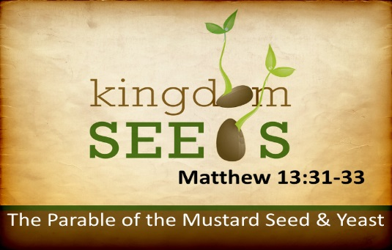
Getting More from the Message – Matthew 13:31-35
Community Group Questions – Week of May 20, 2018
Getting Started: Read this week’s passage out loud & pray the Holy Spirit will help you understand.

Ice Breaker: Why do you think so many people seem discouraged these days? _____________________________________________________________________
- In many of the “great moves of God” the Lord has used young people. Why do you think that is? ______________________________________________________________________________________________________________________________________
- The Bible is often realistic about a “difficult present,” and you also see a future full of hope. Should that make a difference in the way we see the world? Please explain. _____________________________________________________________________________________________________________________________________
- Are you ever discouraged by the lack of believers in our area? Are you ever exposed to people who say they are believers, but live and act like they are not? Please explain. ______________________________________________________________________________________________________________________________________
- Our culture has a view that things have to be BIG to be successful, while the Bible points more to faithfulness and authentic faith as marks of success. Has our culture’s view hindered you? ______________________________________________________________________________________________________________________________________
- The leaven/yeast transforms the dough into bread. What differences or transformation (if any) do have you seen the Holy Spirit making in you? What transformation is happening now? ______________________________________________________________________________________________________________________________________
- Repeatedly, the Bible tells us that God’s people are often stiff-necked and rebellious towards Him. What is your reaction to that? _____________________________________________________________________________________________________________________________________
- Despite the rejection of God’s own people towards Him, He does not give up on them, even sending His beloved Son to die for them. What is your reaction to that? ___________________________________________________________________
- What is a question you would like to ask the group regarding this week’s passage? ___________________________________________________________________
- Was there anything specific you think God wanted you to take away from this week’s passage?
___________________________________________________________________
- How can we pray for you in regards to what we studied this week? Other prayer requests are fine, but we are also looking for a specific prayer request for you in regards to this week’s passage. ___________________________________________________________________

