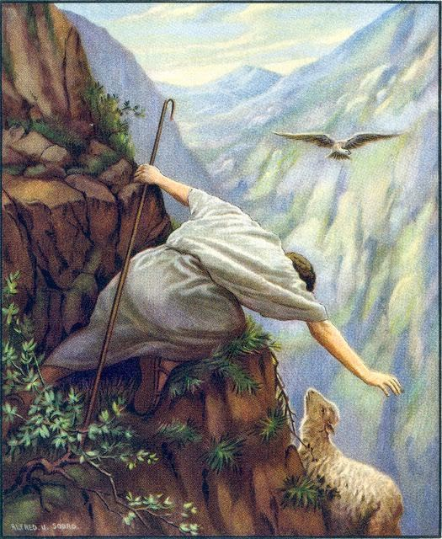
Getting More from the Message – Matthew 18:10-14
Community Group Questions – Week of November 11, 2018
Getting Started: Read this week’s passage out loud & pray the Holy Spirit will help you understand.

Ice Breaker: What are some things you often lose or misplace?
_____________________________________________________________________
- Can you describe what we mean when we say Jesus came “seeking” for you?
______________________________________________________________________________________________________________________________________
- Why do you think many people are hesitant to contact someone when they leave a church or leave the faith? ___________________________________________________________________
- Can you recount an experience of a friend falling away from the faith? What happened and what was that like for you? How did that make you feel?
______________________________________________________________________________________________________________________________________
- Since you have become a Christian (if you haven’t, that’s okay!), have you ever wandered away from the Lord? What was that like? What was the road back like?
______________________________________________________________________________________________________________________________________
- The religious leaders of Jesus’ day looked down on certain people. How can we avoid doing that? ______________________________________________________________________________________________________________________________________
- Many churches feel they are friendly, while guests would say they are friendly only with each other. How can we as a church combat that and set a different tone? (Are you willing to try?)
___________________________________________________________________
- When people wander from Christ and His church, what are some things they may be blind to?
___________________________________________________________________
- Many people feel it’s the pastor’s job to reach out to people. What is the potential if we all did?
___________________________________________________________________
- What was something that challenged you this week? What was something that encouraged you?
______________________________________________________________________________________________________________________________________
- Was there anything specific you think God wanted you to take away from this passage?
___________________________________________________________________
- How can we pray for you in regards to what we studied this week? Other prayer requests are fine, but we are also looking for a specific prayer request for you in regards to this week’s passage. ______________________________________________________________________________

