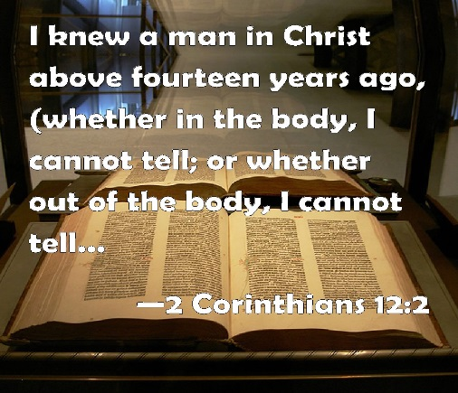
Getting More from the Message – 2 Corinthians 12:1-6
Community Group Questions – Week of November 13, 2016
Getting Started: Read this week’s passage out loud & pray the Holy Spirit will help you understand.

Ice Breaker: What do you find to be the hardest and the easiest spiritual issues to speak with people about?
_____________________________________________________________________
- Why do you think so many people believe their own opinion about God and Heaven is all that really matters?
______________________________________________________________________________________________________________________________________
- Why should we be wary of the opinions of people regarding God and the Bible? ______________________________________________________________________________________________________________________________________
- Have you met anyone who consistently claims to have visions and revelations, or went to a church where the pastor consistently claimed to have visions and revelations? If yes, what was it like?
______________________________________________________________________________________________________________________________________
- What should we do when a person says, “The Lord told me”?
______________________________________________________________________________________________________________________________________
- How do you explain so many bestselling books regarding heaven?
______________________________________________________________________________________________________________________________________
- Despite his incredible ministry, why would the Apostle Paul simply describe himself as “a man”? ______________________________________________________________________________________________________________________________________
- Do you believe people can have personal, life-changing experiences with God? (Please explain.)
______________________________________________________________________________________________________________________________________
- How should the hope of heaven motivate us to live for Christ today and tomorrow?
______________________________________________________________________________________________________________________________________
- How can we pray for you in regards to what we studied and discussed this week? ______________________________________________________________________________________________________________________________________

