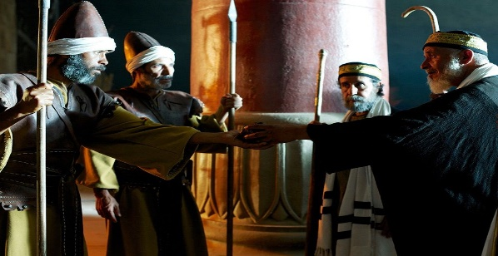
Getting More from the Message – Matthew 28:11-15
Community Group Questions – Week of March 15, 2020

Getting Started: Read this week’s passage out loud & pray the Holy Spirit will help you understand.

Ice Breaker: If you ask a group of people if Jesus actually, physically rose from the dead, what are some of the answers you would expect to hear?
_____________________________________________________________________
- What is the most common thing you have heard regarding the resurrection from unbelievers? ______________________________________________________________________________________________________________________________________
- How important is the resurrection to Christianity? Please explain. ______________________________________________________________________________________________________________________________________
- The religious leaders always seemed to hit a dead end when they came up against Jesus. Since they were the most educated men in the land, what do you think will happen when the “best and the brightest” of our world try to outsmart or out-maneuver Jesus? (See 1 Corinthians 1:18-31.) ______________________________________________________________________________________________________________________________________
- Why do you think so many people have no interest in the things of God? ___________________________________________________________________
___________________________________________________________________
- Did you find the theory that the apostles stole the body credible? Why or why not? ______________________________________________________________________________________________________________________________________
- In light of all the trouble our world is in right now, what (if anything) does the hope of the resurrection mean to you? (Read Revelation 21:1-5.) ______________________________________________________________________________________________________________________________________
- Lord willing, next week we will look at Matthew 28:16-20. Read this passage out loud. What are some things that stand out to you in this passage? ______________________________________________________________________________________________________________________________________
- Please write your own question for the group to answer: ______________________________________________________________________________________________________________________________________
- Was there anything specific you think God wanted you to take away from this passage?
___________________________________________________________________
- How can we pray for you in regard to what we studied this week? Other prayer requests are fine, but we are also looking for a specific prayer request for you regarding this week’s passage. ___________________________________________________________________

