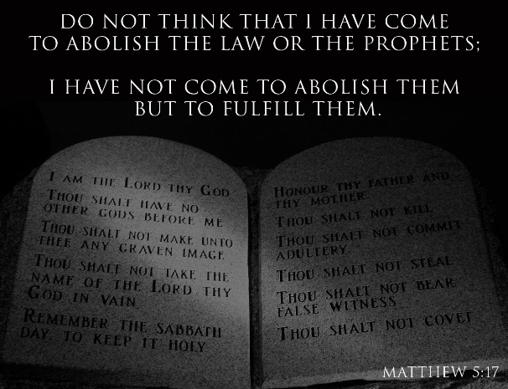
Getting More from the Message – Matthew 5:17-20
Community Group Questions – Week of March 19, 2017
Getting Started: Read this week’s passage out loud & pray the Holy Spirit will help you understand.

Ice Breaker: Can you describe how a message can get changed as it moves from person to person?
_____________________________________________________________________
- What are the various ways people are hearing about & coming to conclusions about Christianity? ______________________________________________________________________________________________________________________________________
- Why are so many people, who say they are Christians, anti-Old Testament?
______________________________________________________________________________________________________________________________________
- What, if any, is your experience of reading and/or studying the Old Testament?
______________________________________________________________________________________________________________________________________
- Why do you think so many churches seem to avoid sermons from the Old Testament? What are some ways you can expose yourself to more Old Testament teaching? ______________________________________________________________________________________________________________________________________
- It has been said that “the Old Testament lacks grace and the New Testament lacks commands.” What is your reaction to that? ______________________________________________________________________________________________________________________________________
- Why do you think Jesus comes down so hard on the religious leaders of His day?
______________________________________________________________________________________________________________________________________
- Can you explain how we can obtain a righteousness greater than some devout religious people? ___________________________________________________________________
- Why do you think many Christians push back so hard on the obedience commands of the Bible? What should our reactions to those texts and commands be? ___________________________________________________________________
- Was there anything specific you think God wanted you to take away from this passage?
___________________________________________________________________
- How can we pray for you in regards to what we studied this week? Other prayer requests are fine, but we are also looking for a specific prayer request for you in regards to this week’s passage. ___________________________________________________________________

