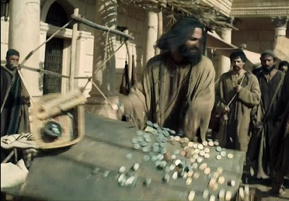
Getting More from the Message – Matthew 21:12-22
Community Group Questions – Week of March 17, 2019
Getting Started: Read this week’s passage out loud & pray the Holy Spirit will help you understand.

Ice Breaker: Many people say that religion has been the cause of many wars and suffering. What do you think about that, and how would you speak with someone about that?
_____________________________________________________________________
- What was your feeling on certain people not being allowed to go into certain places in the temple? ___________________________________________________________________
- What effect does a “corrupt church” that is allowed to continue have on our culture? How would you answer someone who says they don’t attend church because of all the scandals?
______________________________________________________________________________________________________________________________________
- How do you reconcile the fact that a church needs money to operate, and yet church should not be “about the money”? How should the topic be approached? (What are some of the expenses?)
______________________________________________________________________________________________________________________________________
- Why do you think so many people think just going to church is what God desires from them? What would you say to someone who was taught that, and feels “just going” is a waste of time? ______________________________________________________________________________________________________________________________________
- What do you think a fruitful Christian life looks like? What are some ways people confuse “Christian activity” with fruitfulness?
______________________________________________________________________________________________________________________________________
- What are some things that take people from a fruitful Christian life to a fruitless Christian life? How do you think Israel get so far off course? If you had a friend that had gotten off course, how would you counsel them to get back to fruitfulness?
______________________________________________________________________________________________________________________________________
- Is there a mountain of unbelief you would like to see moved? Please explain. ___________________________________________________________________
- Was there anything you wanted to ask or say to the group this week?
___________________________________________________________________
- Was there anything specific you think God wanted you to take away or change from this passage?
___________________________________________________________________
- How can we pray for you in regards to what we studied this week? Other prayer requests are fine, but we are also looking for a specific prayer request for you in regards to this week’s passage. ______________________________________________________________________________

