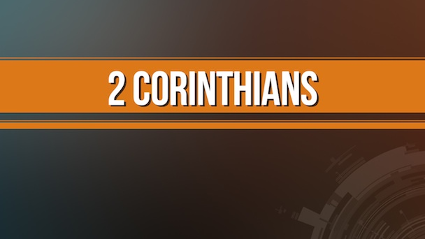
Getting More from the Message – 2 Corinthians 12:7-10
Community Group Questions – Week of 11-27-16
Getting Started: Read this week’s passage out loud & pray the Holy Spirit will help you understand.

Ice Breaker: How has suffering changed you?
_____________________________________________________________________
- What do we mean by God’s sufficient grace? Do you have an experience of it you can share?
______________________________________________________________________________________________________________________________________
- How can an event in our lives cause us to move away from the Lord or move us closer to Him? ______________________________________________________________________________________________________________________________________
- Why is it that people most often come to faith in Jesus Christ in the midst of great pain?
______________________________________________________________________________________________________________________________________
- What is a thorn in the flesh? Can you give an example of God’s strength in the midst of weakness?
______________________________________________________________________________________________________________________________________
Getting More from the Message – 2 Corinthians 13:5-10
- Why do most people view their sin as not so bad?
______________________________________________________________________________________________________________________________________
- Why do you think the Apostle Paul called the Corinthian church to examine themselves as to whether or not they were in the faith? Is this something we should do? Why or why not? ______________________________________________________________________________________________________________________________________
- Many church people say it doesn’t matter how we live since the Lord forgives all our sins anyway. What is your reaction to that? Do you agree or disagree, and why?
______________________________________________________________________________________________________________________________________
- Can you share anything you have learned about yourself through self-examination?
______________________________________________________________________________________________________________________________________
- How can we pray for you in regards to what we have been talking about? ______________________________________________________________________________________________________________________________________

