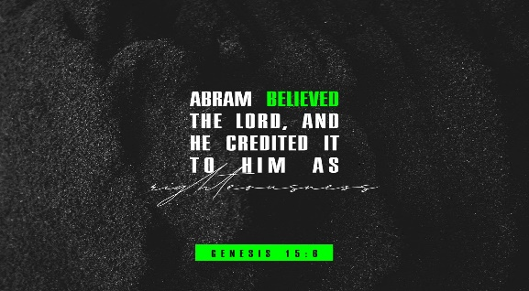
Getting More from the Message – Genesis 15:1-6
Community Group Questions – Week of November 1, 2020
Getting Started: Read this week’s passage out loud & pray the Holy Spirit will help you understand.

Ice Breaker: How would you respond to someone who says, “God is not good”?
_____________________________________________________________________
- Many of us have felt that God can be slow on the delivery of His promises. Have you learned any lesson(s) from His slow delivery? Please explain.
______________________________________________________________________________________________________________________________________
- What are some of the things of which Christians seem to be most afraid? (Are you willing to share one of your fears? – Can be serious or funny!) ______________________________________________________________________________________________________________________________________
- By letting us “vent” to Him, how do you think God can grow our faith? How can “venting” to God be a sign of faith?
______________________________________________________________________________________________________________________________________
- Why is it far better to lay our cares and concerns at the feet of Jesus rather than bottling them up?
______________________________________________________________________________________________________________________________________
- What does the following expression mean to you: “God’s delays are not God’s denials”?
___________________________________________________________________
- Why do you think it is so hard to explain to people (and get them to understand) that we enter heaven through faith in Jesus Christ and not through “being a good person”? ______________________________________________________________________________________________________________________________________
- Read Romans 3:10-11 out loud. What hope do we have of getting to heaven apart from Jesus?
______________________________________________________________________________________________________________________________________
- How does faith and trust in Jesus remove our sins and give us the righteousness of God?
___________________________________________________________________
- Was there anything you wanted to ask or say to the group this week?
___________________________________________________________________
- Was there anything specific you think God wanted you to take away or change from this passage?
___________________________________________________________________
- How can we pray for you in regards to what we studied this week? Other prayer requests are fine, but we are also looking for a specific prayer request for you in regards to this week’s passage. ______________________________________________________________________________

