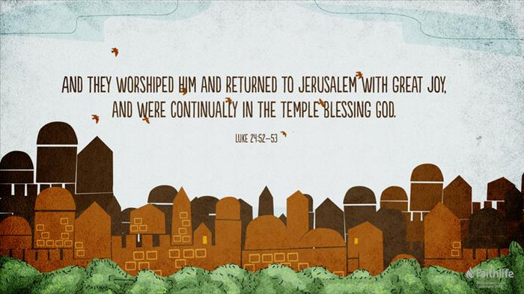
Getting More from the Message – Luke 24:50-53
Community Group Questions – Week of December 2, 2018
Getting Started: Read this week’s passage out loud & pray the Holy Spirit will help you understand.

Ice Breaker: Why do you think many people don’t notice the blessings they already have?
_____________________________________________________________________
- What is the difference between the blessings God has for believers and those who don’t believe?
______________________________________________________________________________________________________________________________________
- A.W. Tozer said that believing that lots of activity makes a man or a woman dear to God is heresy. Do you agree or disagree? (Have you ever seen a church with too much extra activity?) ______________________________________________________________________________________________________________________________________
- What does it mean to live our lives out of God’s blessing instead of trying to get God’s blessing?
______________________________________________________________________________________________________________________________________
- What do you think about the idea that some people believe that God is holding out on them and they have to go after the blessing themselves?
______________________________________________________________________________________________________________________________________
- Why do you think many followers of Jesus lack joy? ______________________________________________________________________________________________________________________________________
- What did you think when you heard about how the Lord loved you before you were even born?
___________________________________________________________________
- Many Christians are tired of the combination of the American way of life and the Christian way of life. What is your advice for them?
___________________________________________________________________
- What was something that challenged you this week? What was something that encouraged you?
______________________________________________________________________________________________________________________________________
- Let’s pretend you meet someone who is considering joining a Community Group, and you know they will benefit from joining. In your own words, write 1-3 paragraphs telling what being in a group has meant to you and how it has helped you. - (Use the back of the sheet.)

- Was there anything specific you think God wanted you to take away from this week’s passage?
___________________________________________________________________
- How can we pray for you in regards to what we studied this week? Other prayer requests are fine, but we are also looking for a specific prayer request for you in regards to this week’s passage. ___________________________________________________________________

