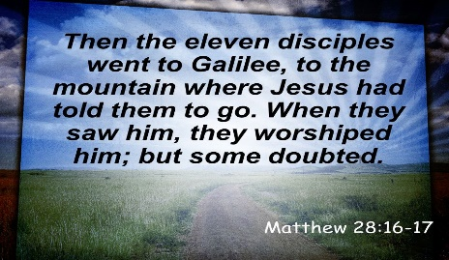
Getting More from the Message – Matthew 28:16-17
Community Group Questions – Week of March 22, 2020

Getting Started: Read this week’s passage out loud & pray the Holy Spirit will help you understand.

Ice Breaker: How do you think most people feel about change?
_____________________________________________________________________
- Can you explain what the Great Commission is? (Read verses 18-20.) ______________________________________________________________________________________________________________________________________
- The Lord uses imperfect people to build His church. Why do you think that is? How does that make you feel? ___________________________________________________________________
- What, if any, effect do you see the Coronavirus having on the faith of people who claim to be Christians, but give no evidence of it? What if any, effect do you see the Coronavirus having on the faith of people who are not followers of Jesus? ______________________________________________________________________________________________________________________________________
- If churches are not allowed to gather for a long time, do you think most people will come back to church, or will they have gotten into the habit of not attending? (Many site getting out of the habit of attending church as the number one reason people do not attend church any longer.) ___________________________________________________________________
- Did God speak to you in any way when Matthew mentioned the “eleven” instead of the “twelve”? ______________________________________________________________________________________________________________________________________
- What are some ways you think the Lord is stretching your faith in the current crisis? ______________________________________________________________________________________________________________________________________
- Read Romans 12:1-2 out loud. While many people limit worship to music, how does this passage and our passage in Matthew (or if you know of other passages) expand your view of worship?
______________________________________________________________________________________________________________________________________
- Jesus seems comfortable with our doubts. What does that mean to you? Are there any doubts you have that we can pray for?
______________________________________________________________________________________________________________________________________
- Please write your own question for the group to answer: ___________________________________________________________________
- Was there anything specific you think God wanted you to take away from this passage?
___________________________________________________________________
- How can we pray for you in regard to what we studied this week? Other prayer requests are fine, but we are also looking for a specific prayer request for you regarding this week’s passage. ___________________________________________________________________

