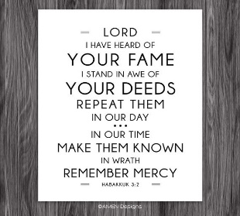
Getting More from the Message – Habakkuk 3:1-2
Community Group Questions – Week of June 7, 2020
Getting Started: Read this week’s passage out loud & pray the Holy Spirit will help you understand.

Ice Breaker: Did you ever forget to open a gift, only to find out later it was a great gift? What was it?
_____________________________________________________________________
- Why do you think we often skip over or pay less attention to the prayers in the Bible? God put the prayers of the Bible writers in the Bible - what are some important reasons why He did that?
______________________________________________________________________________________________________________________________________
- What do you think needs to change about the way we pray individually and as a group? ______________________________________________________________________________________________________________________________________
- How do you think our prayers can be or should be connected to what we are learning in the Bible?
______________________________________________________________________________________________________________________________________
- Has the Lord ever used painful circumstances in your life to draw you closer to Him? If you feel comfortable, please share it with the group. (It will probably bless everyone!)
______________________________________________________________________________________________________________________________________
- The people in Habakkuk’s day had lost touch with God. Do you think self-centeredness has replaced Christ-centeredness among Christians today? Do you think the acceptance of sin among professing Christians has gone too far? (It is great if you can cite examples) ______________________________________________________________________________________________________________________________________
- In verse 2, Habakkuk prayed, “Lord, revive Your work.” How does the Lord need to revive His work in us individually and revive it in His church? What is our part in that? ______________________________________________________________________________________________________________________________________
- Most people do not like the idea of “God’s wrath.” How can we connect it to the cross for them?
______________________________________________________________________________________________________________________________________
- Was there anything you wanted to ask or say to the group this week?
______________________________________________________________________________________________________________________________________
- Was there anything specific you think God wanted you to take away or change from this passage?
___________________________________________________________________
- How can we pray for you in regards to what we studied this week? Other prayer requests are fine, but we are also looking for a specific prayer request for you in regards to this week’s passage. ______________________________________________________________________________

