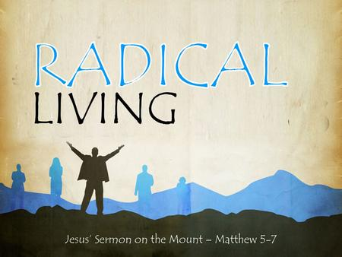
Getting More from the Message – Matthew 5:27-30
Community Group Questions – Week of April 2, 2017
Getting Started: Read this week’s passage out loud & pray the Holy Spirit will help you understand.

Ice Breaker: How have you seen the attitudes toward sex change in our country during your lifetime?
_____________________________________________________________________
- Our culture seems to feel we should do “whatever makes you happy.” What are your thoughts on that? (How have you seen this hurt people?) ______________________________________________________________________________________________________________________________________
- Pornography has become an epidemic in our country. Why are people reluctant to talk about it?
______________________________________________________________________________________________________________________________________
- How can Christ’s forgiveness help us face the truth(s) about ourselves?
______________________________________________________________________________________________________________________________________
- How would you counsel a friend who had a big problem with lust, if that friend thought it would just go away on its own? If you wanted to help, what are some ways you might? ___________________________________________________________________
- Why do you think each generation comes up with its own ethics? What do you feel the contemporary American Christian sexual ethic is & does it agree or conflict with Jesus? (Explain)
______________________________________________________________________________________________________________________________________
- Why do you think Jesus is so serious about this topic? (Are Christian churches serious enough?) ______________________________________________________________________________________________________________________________________
- How should we be encouraging our single people in this sensitive area? How should we be encouraging our married people in this sensitive area? ___________________________________________________________________
- Jesus advised we “cut off” whatever leads us to sin. What does that mean and how does the gospel help us do that? ___________________________________________________________________
- Was there anything specific you think God wanted you to take away from this week’s passage?
___________________________________________________________________
- How can we pray for you in regards to what we studied this week? Other prayer requests are fine, but we are also looking for a specific prayer request for you in regards to this week’s passage. ___________________________________________________________________

