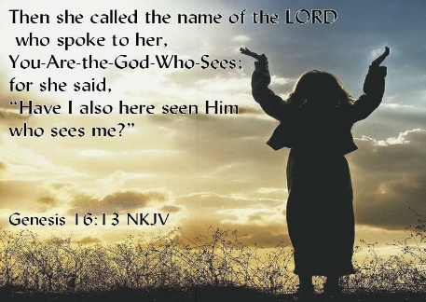
Getting More from the Message – Genesis 16:1-16
Community Group Questions – Week of November 15, 2020
Getting Started: Read this week’s passage out loud & pray the Holy Spirit will help you understand.

Ice Breaker: Do you know what it is like being around an extremely bitter person? Please explain.
_____________________________________________________________________
- Have you ever felt like your faith failed? If yes, what did that feel like? Do you still feel that way?
______________________________________________________________________________________________________________________________________
- Have you ever felt like you were abandoned by God? If yes, what did that feel like? Do you still feel that way?
______________________________________________________________________________________________________________________________________
- Sarai has been waiting for God’s promises for ten years. We have been living through Covid for eight months. What are some practical things we can do to keep ourselves in the faith?
______________________________________________________________________________________________________________________________________
- When do you find yourself vulnerable to temptation?
______________________________________________________________________________________________________________________________________
- Why do you think God wants us to feel the pain of the people in the Bible?
______________________________________________________________________________________________________________________________________
- What do you think the effect of impatience is on us when we are waiting on God? ______________________________________________________________________________________________________________________________________
- Why is it necessary that we repent of our sins to have a true experience with Christ?
______________________________________________________________________________________________________________________________________
- Have the sin and messiness of your life made you love Jesus more? If yes, how would you explain that to a friend?
___________________________________________________________________
- Was there anything you wanted to ask or say to the group this week?
___________________________________________________________________
- Was there anything specific you think God wanted you to take away or change from this passage?
___________________________________________________________________
- How can we pray for you in regards to what we studied this week? Other prayer requests are fine, but we are also looking for a specific prayer request for you in regards to this week’s passage. ______________________________________________________________________________

