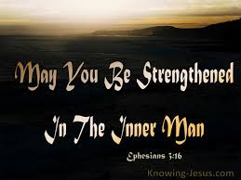
Getting More from the Message – Ephesians 3:14-17
Community Group Questions – Week of October 7, 2018
Getting Started: Read this week’s passage out loud & pray the Holy Spirit will help you understand.

Ice Breaker: Many people who don’t follow Jesus say they pray. What do you think they pray for? _____________________________________________________________________
- Why do you think many Christians are okay with requesting prayers for others, but not themselves? ______________________________________________________________________________________________________________________________________
- Most of our prayer requests center on temporary things such as jobs, health etc. Why do you think that is? _____________________________________________________________________________________________________________________________________
- What do you think your life would be like if you were strengthened more in the “inner man?” ______________________________________________________________________________________________________________________________________
- What does it mean to have Christ dwell in our hearts? ______________________________________________________________________________________________________________________________________
- What are some of the reasons you think it is difficult for people to grasp the love of Christ? What do you think the reasons are that it is hard for you to grasp His love for you and what would be different in your life as you experience it more? ______________________________________________________________________________________________________________________________________
- God wants to offer and give Himself to you. He proved it by sending Jesus Christ to die your your sins, so you could appear before God forgiven and clean. What are your thoughts about that? _____________________________________________________________________________________________________________________________________
- Is there any question you would like to ask the group related to this portion of scripture or these concepts? ___________________________________________________________________
- Was there anything specific you think God wanted you to take away from this week’s passage?
___________________________________________________________________
- How can we pray for you in regards to what we studied this week? Other prayer requests are fine, but we are also looking for a specific prayer request for you in regards to this week’s passage. ___________________________________________________________________

