Chapel of the Cross
Summer Camp Calendar 2021
Daily Schedule
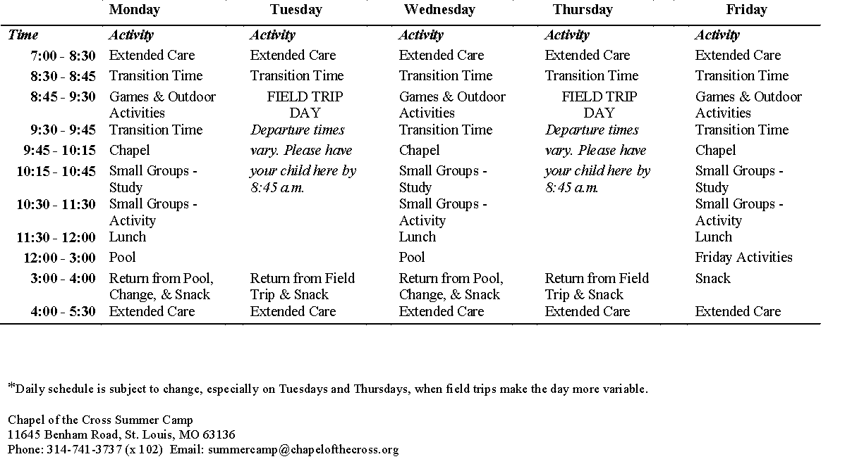
June 2021

SUNDAY | MONDAY | TUESDAY | WEDNESDAY | THURSDAY | FRIDAY | SATURDAY
 | MAY 31 | June 1 | June 2 | 3 | 4 | 5
Weekly Theme  #OurAuthor | Memorial Day Holiday
6 | 7 | 8 | 9 | 10 | 11 | 12
Weekly Theme  #OurServant | First Day of Camp Swimming  Bellefontaine Pool | Field Trip  Spanish Lake Park | Swimming  North Co Rec Pool | Field Trip  Skating  SkatePort Plaza | Weekly  Adventure
13 | 14 | 15 | 16 | 17 | 18 | 19
Weekly Theme #OurPromise | Gr. K-5 – Swimming  Bellefontaine Pool  Gr 6-8 – LHSN Crusader Academy | Gr. K-5 - Field Trip  Woodland Park  Gr 6-8 – LHSN Crusader Academy | Gr. K–5 – Swimming  North Co Rec Pool  Gr 6-8 – LHSN Crusader Academy | Field Trip  Gr. K-5 - Magic House  Gr 6-8 – LHSN Crusader Academy | Gr. K-5 - Weekly Adventure  Gr 6-8 – LHSN Crusader Academy
20 | 21 | 22 | 23 | 24 | 25 | 26
Weekly Theme  #OurSacrifice | Swimming  White Birch Bay Aquatic Center | Field Trip  Bird Sanctuary | Swimming  North Co Rec Pool | Science Center | Weekly  Adventure
27 | 28 | 29 | 30
Weekly Theme  #OurForgiver | Swimming  Bellefontaine Pool | Field Trip  Grants Farm | Swimming  North Co Rec Pool
July 2021

SUNDAY | MONDAY | TUESDAY | WEDNESDAY | THURSDAY | FRIDAY | SATURDAY
 |  |  |  | July 1 | July 2 | 3
 |  |  |  | Field Trip  Vago Park  Edwardsville, IL | Weekly  Adventure
4 | 5 | 6 | 7 | 8 | 9 | 10
Weekly Theme  #OurStrength | No Camp | Field Trip  St Louis Zoo | Swimming  North Co Rec Pool | Field Trip  Laumeier Park | Weekly  Adventure
11 | 12 | 13 | 14 | 15 | 16 | 17
Weekly Theme  #OurLife | Swimming  Aquaport | Field Trip  Botanical Gardens | Swimming  North Co Rec Pool | Field Trip  Creve Coeur Park | Weekly  Adventure
18 | 19 | 20 | 21 | 22 | 23 | 24
Weekly Theme  #OurJoy | Swimming  Bellefontaine Pool | Field Trip  Skating Port Plaza/ Queeny Park | Swimming  North Co Rec Pool | Field Trip  Movies | Weekly  Adventure
25 | 26 | 27 | 28 | 29 | 30 | 31
Weekly Theme  #Recap  CAMP LED WORSHIP SERVICE – 11 AM | Swimming  Bellefontaine Pool | Field Trip  Shaw Park | Swimming  North Co Rec Pool | Field Trip  City Museum | Weekly Adventure

August 2021

SUNDAY | MONDAY | TUESDAY | WEDNESDAY | THURSDAY | FRIDAY | SATURDAY
Aug 1 | Aug 2 | 3 | 4 | 5 | 6
#Reflection | Swimming  Bellefontaine Pool | Field Trip  Camp Favorite Park | Swimming  North Co Rec Pool | Field Trip  Skyzone | Last Day of Camp

Phone: 314-741-3737 Ext. 102 Email: summercamp@chapelofthecross.org
Field Trip Schedule is subject to change due to availability of venue and/or weather conditions (rain, heat, etc.)
Some field trips require pre-purchased tickets and/or extra staff to meet required staff to camper ratio. Summer Camp reserves the right to charge a $10 fee for missing these days unless cancelled one week in advance.

