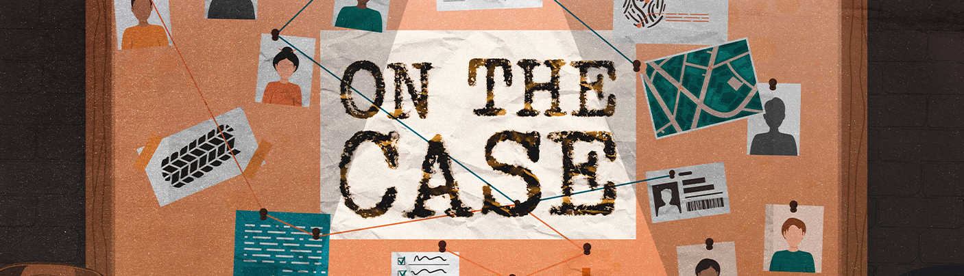

**June 2-3, 9AM-12PM**

**$10 cost to register**

**CITYPRESABQ.COM**

**what to know**

**Volunteer sign-up link:**

<https://www.signupgenius.com/go/904044DA9A62AA5F49-city>

**Supply donation link:**

<https://www.signupgenius.com/go/904044DA9A62AA5F49-vbssupply>

**contact**

Rachel Whippo

childrensministry@citypresabq.com

Hey friends! We are just a few weeks away from our summer VBS! We can’t wait to see how this summer grows kids’ connections with God and with others. Before VBS begins, though, we wanted to make sure you had all the most up-to-date information. Please check the sign-up links for Volunteer positions and for supply donations! Please let us know if you have any questions by shooting us an email. See you soon!

**Schedule**

Kids can be dropped off at 8:45AM, VBS begins at 9. Pick up will be at 12PM.

* 8:45-9:00 AM - Check-in
* 9:00-10:00 - VBS Programming
* 10:00- 10:30- Snack
* 10:30-12:00 - VBS Programming, Part 2
* 12:00 PM - Pick-up

**volunteers**

* Activity Leader/Junior Helper: 2 needed
* Storytime Leader/Junior Helper: 2 needed.
* Craft Leader/Junior Helper: 2 needed.
* Snack Leader: 2 needed.
* Group Leaders/Junior Helpers: 4+ needed.

**stuff to bring**

* bottle of water.
* Bible.
* secure shoes (avoid sandals and slippers).
* hats and sunblock lotion (for outdoor play).
* change of clothes for emergencies (for younger kids).

**stuff not to bring**

* food, unless they are for health reasons.
* water balloons, guns, other water toys.
* skateboards, roller skates, roller blades. . . okay, if it has wheels, don't bring it.
* cell phones, handheld gaming devices, and other electronics.
* anything that resembles a weapon.