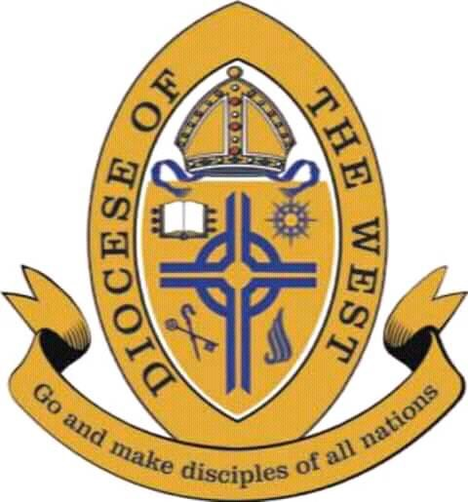

Anglican Diocese of the West

9th Annual Synod Agenda Via Zoom

Friday, May 14 - Saturday, May 15
Synod Host: The Rt. Rev. Dr. Felix & Lilian Orji.
Master of Ceremonies: The Rt. Rev. Celestine Ironna
Synod Secretary: The Rev. Canon Tosin Onaseso

all times Central Standard (CST)
(Agenda subject to Minor Revisions)

Friday, May 14

- 7:00 - 7:45 pm: Evening Prayer by Holy Trinity Cathedral, Houston, TX - The Venerable Chukwuma Ubadinobi
- 7:45 - 8:20 pm: Crown Academy of Liturgical Music (CALM) - The Venerable Aaron Ajoku
  - Quorum, Declaration of Synod Open, & House Keeping
- 8:30 - 10:00 pm: Episcopal Address by the President of the Synod - The Rt. Rev. Dr. Felix Orji
  - Appreciation of the Bishop’s Address – The Rt. Rev. Celestine Ironna
- 10:00 - 10:15 pm: A Briefing by the Diocesan Medical Director - Dr. Obiageli Obijiofor
- 10:15 pm: Benediction - The Rt. Rev. Dr. Felix Orji

Saturday, May 15

- 9:00 - 9:30 am: Morning Prayer by St Georges Anglican Church, Colorado Springs, CO - The Venerable Don Armstrong
- 9:30 - 10:20 am: Bible Teaching, Part 1 - The Most Rev. Dr. Ben Kwashi
- 10:35 - 11:10 am: Mission & Ministry Reports & Testimonies - The Rt. Rev. Dr. Scott Seely
  - Church Planting - The Rev. Canon Segun Adebogun, the Very Rev. Barry Kowald, & The Rev. Dr. Marcus Tinajero
  - Young Adults - The Venerable Barnabas Emenogu
- 11:15am - 12:15 pm: Diocesan Business
  - Diocesan Board Election by the Diocesan Chancellor - Mr. Christopher Milner
  - Financial Report by the Diocesan Treasurer - Sir Charles Napier
- 12:15 - 1-30 pm: Lunch Break
- 1:30-2:30 pm: Bible Teaching, Part 2 - The Most Rev. Dr. Ben Kwashi
- 2:35 pm: Synod Conclusion
  - Closing Worship by Holy Trinity Cathedral, Houston, TX - The Venerable Chukwuma Ubadinobi
  - Bishop’s Final Address - The Rt. Rev. Dr. Felix Orji
  - Dismissal of Synod - The Rt. Rev. Dr. Felix Orji

