CANA West Church Planting Process
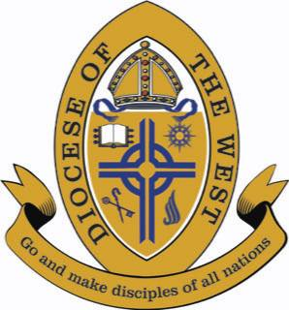
- Contact the Diocesan Office and Archdeacon for Church Planting
Contact the Diocesan office and talk with the Archdeacon for Church Planting for approval to plant a church. Determine the resources and training available. Discuss the process and build a relationship.
- Take an Assessment
This is a more in-depth look at the planter’s calling, character, capacity, gifts, skills, life situation, and ordination stage. An assessment is not pass/fail, but it is a low-overhead tool to quickly gain helpful details about the potential planter.
- Get Connected Locally
Develop and build relationships within the local Archdeaconry: i.e. the Regional Archdeacon, Rectors, and other planters. If in a geographical area where no CANA West churches are present, connect with other ACNA jurisdictions for solidarity and collaboration.
- Get Training
Get equipped to plant a healthy church by reading the CANA West recommended literature, boot camps, conferences, retreats, and podcasts.
- Find a Coach
Discern and hire a coach for guidance and mentoring to plant a healthy church through regular phone calls.
- Develop a Church Planting Ministry Plan
Put together a strategic plan for the church plant: 1) envision phase, 2) implementation phase I, 3) implementation phase II, and 4) multiplication phase. The ministry plan includes timelines, finances, demographical information, launch team, marketing, discipleship and leadership pipelines, and what will be needed for the church plant to becoming a church planting church.
- Launch the Church
Execute the strategic plan, build a launch team, conduct a soft-launch season, and launch the church.

