____________________________________________________

14th August, 2016

Clergy and Vestry of Parishes
The Missionary Diocese of CANA West USA & Canada

RE: THE RECTOR, THE VESTRY, AND PARISH FINANCES

This an important reminder to all Clergy and Vestry of parishes in the Diocese that in accordance with the Canons & Constitution of the Diocese, Rectors are the spiritual leaders of the parish as well as the Chairman of the Vestry having the role of providing spiritual and administrative leadership.

However, it is very important to note that the Rector is not the financial comptroller of the parish and should not obligate or bind the parish financially without the consent of the Vestry. It is the role of the Vestry to manage the finances of the Church and ensure that Finances are available and used to carry out the ministry and mission of Christ in the parish.

May the Lord bless you all as Rectors and Vestries work together for the growth of the body of Christ. Amen.

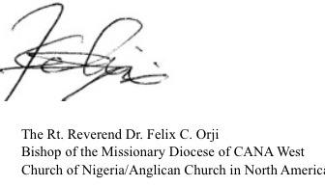
In Christ,

