Getting the Most Out of Your Bible

I. Where we’re headed

A. Step 1: OBSERVATION: What does the Bible say?

B. Step 2: INTERPRETATION: What does the Bible mean?
C. Step 3: APPLICATION: How does the Bible apply?

D. Step 4: CORRELATION: How does the Bible fit together?

II. Today’s lesson: INTERPRETATION: What does the Bible mean?

A. An important starting point: ‘Authorial intent’

- Definition: The original purpose for which the author wrote and the meaning they intended to communicate.

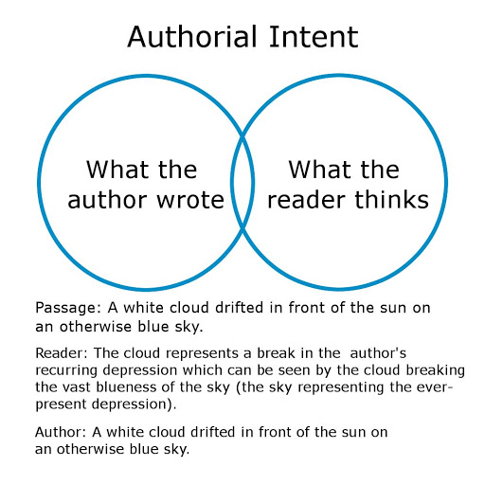

- The Bible cannot mean whatever we want it to mean (“To me, this verse means…”)

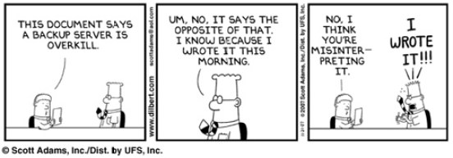
B. Always read the Bible ‘literally’

- What do we mean by ‘literally’? To read Scripture with an eye for understanding it according to its various literary forms and genres. We read it as we would any other piece of literature. We take nouns as nouns, verbs as verbs, poetry as poetry, metaphors as metaphors, etc. (Ex. John 10:9)
- Avoid allegorical interpretation (looks for deeper, hidden, spiritual meanings in the text)

From GotQuestions.org: In his Portraits of Christ in Genesis, M. R. DeHaan says that Adam is a type of Christ because Adam was put to sleep, his side was opened—he was wounded and his blood was shed—and from that wound his bride was taken. In the same way, Christ died, had His side pierced, and from that ordeal His Bride, the church, is produced.

- Aim for the ‘plain meaning of Scripture’: What is the plain, ordinary, straightforward meaning of the verse? (Ex. Matthew 8:23)

John Calvin: “The true meaning of Scripture is the natural and obvious meaning; and let us embrace and abide by it resolutely. Let us not only neglect as doubtful, but boldly set aside as deadly corruptions, those pretended expositions, which lead us astray from the natural meaning.”

C. Strategies for interpreting the Bible

1. Before you begin: Pray! (Psalm 119:18)
2. Reading strategies
- Read the passage repeatedly (at least 3 readings)
- Read slowly
- Read the passage in context (i.e., what comes before & after the passage you’re studying)
- Ask questions as you read (Who? What? When? Why? Where?)
3. Study strategies (without resources)
- Meditate on the passage (Psalm 1:2, the Hebrew word translated ‘meditate’ literally means ‘to mutter (to oneself)’
- Observe details in the passage (look for things emphasized, repeated, related, things that are alike and unlike)

1 John 1:1-4
That which was from the beginning, which we have heard, which we have seen with our eyes, which we looked upon and have touched with our hands, concerning the word of life— ² the life was made manifest, and we have seen it, and testify to it and proclaim to you the eternal life, which was with the Father and was made manifest to us— ³ that which we have seen and heard we proclaim also to you, so that you too may have fellowship with us; and indeed our fellowship is with the Father and with his Son Jesus Christ. ⁴ And we are writing these things so that our joy may be complete.

- Pay attention to words, phrases, clauses (practice on 1 John 1:1-4 again)
- Try to trace the author’s train of thought (again, practice on 1 John 1:1-4)
4. Study strategies (with resources)
- Check cross-references (cf. cross-references on 1 John 1:1-4)

The Analogy of Scripture: the principle that Scripture is its own best interpreter

- Use Bible dictionaries/encyclopedias/atlases
- Use word study resources
- Use concordances
- Use a study Bible
- Read ‘good’ commentaries

D. Recommended Resources

