Getting the Most Out of Your Bible

I. Where we’re headed:

A. Step 1: OBSERVATION: What does the Bible say?

B. Step 2: INTERPRETATION: What does the Bible mean?
C. Step 3: APPLICATION: How does the Bible apply?

D. Step 4: CORRELATION: How does the Bible fit together?

II. Today’s lesson: OBSERVATION: What does the Bible say? (Reading)

A. Disturbing trends in Bible reading

- From Christianity Today: Between early 2019 and 2020, the percentage of US adults who say they use the Bible daily dropped from 14 percent to 9 percent, according to the State of the Bible 2020 report…by the Barna Group and the American Bible Society (ABS). A decrease of 5 percentage points in a single year was unprecedented in the annual survey’s 10-year history; between 2011 and 2019, daily Bible readers had basically held steady at an average of 13.7 percent of the population. But the decline continued during the initial months of the coronavirus pandemic, and by June, the percentage of daily Bible users had dropped to 8.5 percent.

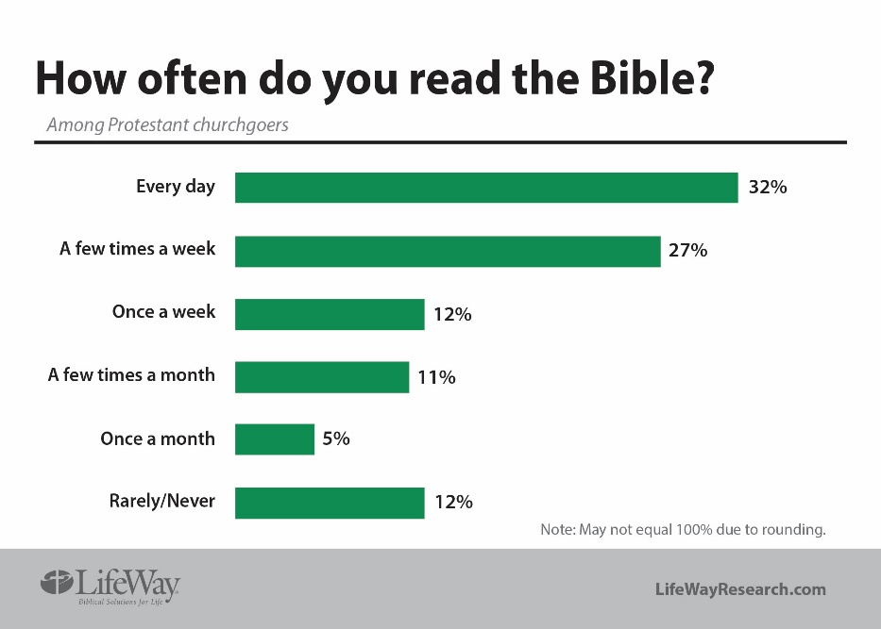

- A crisis of biblical illiteracy
- How can we really know God?

B. Why read the Bible?
- It’s the word of God (2 Tim. 3:16)
- God speaks to us in the word (Heb. 1:1-2)
- It contains the truth of God (John 17:17; Ps. 19:7, 9; 12:6; 119:151)
- It’s infallible in its totality (Ps. 19:7)
- It’s inerrant in its parts (Pr. 30:5-6)
- It makes us wise unto salvation (2 Tim. 3:15)
- It’s the means of our growth in faith (1 Pet. 2:2)
- It’s the means of our sanctification (Ps. 119:9, 11; John 17:17)
- It’s sufficient for every need (2 Tim. 3:16-17)
- It illumines life’s pathway (Ps. 119:105)
- It’s the source of encouragement (Rom. 15:4)
- It keeps us from falling into error (implied in Matt. 22:29; Mk 12:24)
- It’s our weapon in spiritual warfare (Eph. 6:17)
- God blesses those who read and do it (Rev. 1:3)

C. Barriers to reading the Bible and how to overcome them
- Are you saved? (the problem of an unregenerate heart; 1 Cor. 2:14)
- “I don’t have enough time to read the Bible” (2 Tim. 2:15)
- “I’m not motivated to read the Bible”
John Piper’s prayer method:
I, Incline my heart to your testimonies (Psalm 119:36).
O, Open my eyes to see wonderful things (Psalm 119:18).
U, Unite my heart to fear your name (Psalm 86:11).
S, Satisfy me in the morning with your steadfast love (Psalm 90:14).
- “I don’t understand the Bible” (Acts 17:11)
- “I always get distracted when I read the Bible”
- “Reading the Bible is boring”
- “I don’t see the relevance of the Bible to my life” (1 Tim. 3:16-17; 1 Cor. 10:6, 11)
- “I have difficulty reading”
- “There are too many translations of the Bible. Which one do I choose?”
- “The Bible is too long”

D. Some common (but mostly ineffective) approaches to reading the Bible
- The “Pearls on a string” approach (We read the Bible as if it were merely a collection of spiritual nuggets)
- The “Devotional” approach (We only read the verses in our devotional book)
- The “Buckshot” approach (There’s no rhyme or reason to our reading; we read multiple verses across multiple books)
- The “Buffet” approach (We skip from verse to verse, and from paragraph to paragraph in one biblical book)

E. Best Practices for reading the Bible
- Read entire books in one sitting
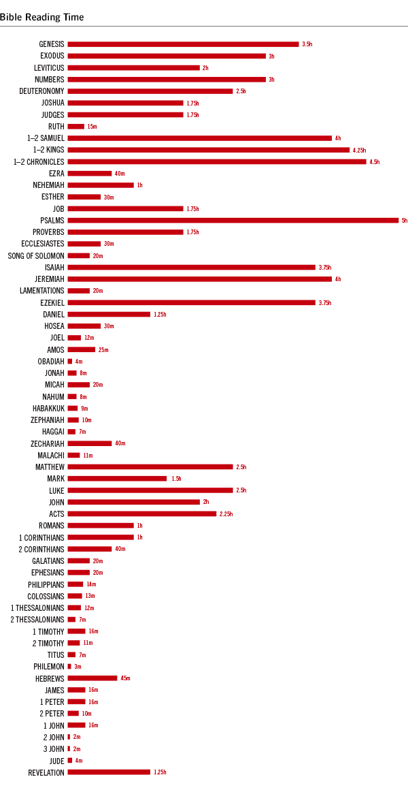
- Read several chapters at a time
- Stay in one book until finished
- Focus on content, not necessarily understanding
- Read 4 chapters a day
- Read in the morning & evening
- Experiment with one year Bible reading plans
- Keep reading (even if you don’t understand something)
- Read books and chapters repetitiously
- Read actively (your best time of the day)
- Experiment with e-readers
- Choose a good translation
- Listen to audio Bibles (especially for the genealogies)
- Try to ignore the chapter and verse markings
- Pray before you read
- Pray as you read
- My personal Bible reading method: choose a book from the OT and the NT and read them at the same time. Read until finished.

F. Some helpful resources

