259. THE JERUSALEM COUNCIL
(ACTS 15:1-29)

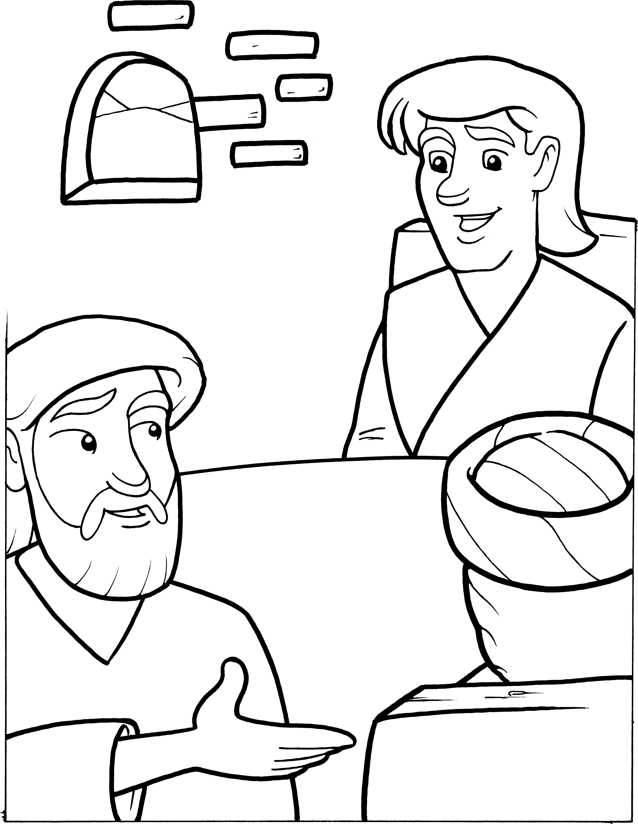

“And the apostles and elders came together for to consider of this matter.”
ACTS 15:6

