259. THE JERUSALEM COUNCIL
(ACTS 15:1-29)

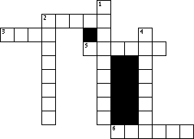

5 | ACROSS | "And certain men came down from Judea and taught the brethren, 'Unless you are circumcised according to the________of Moses, you cannot be saved.' " ACTS 15:1
1 | DOWN | "Therefore, when Paul and Barnabas had no small dissension and dispute with them, they determined that Paul and Barnabas and certain others of them should go up to , to the apostles and elders, about this question." ACTS 15:2
4 | DOWN | "So the apostles and elders came____to consider this matter." ACTS 15:6
3 | ACROSS | "Now therefore, why do you test God by putting a ________on the neck of the disciples which neither our fathers nor we were able to bear?" ACTS 15:10
2 | ACROSS | "But we believe that through the_____ of the Lord Jesus Christ we shall be saved in the same manner as they." ACTS 15:11
2 | DOWN | "And after they had become silent, James answered, saying, 'Men and brethren, listen to me: Simon has declared how God at the first visited the_____to take out of them a people for His name.' " ACTS 15:13-14
6 | ACROSS | "For it seemed good to the Holy Spirit, and to us, to lay upon you no greater_____ than these necessary things: that you abstain from things offered to idols, from blood, from things strangled, and from immorality. If you keep yourselves from these, you will do well." ACTS 15:28-29

