April 20, 2017

“The LORD said to Moses, ‘This applies to the Levites: Men twenty-five years old or more shall come to take part in the work at the Tent of Meeting, but at the age of fifty, they must retire from their regular service ….. They may assist their brothers in performing their duties…’” Numbers 8:23-26

Dear Brothers and Sisters of Faith,

In light of the brevity of life, the stewarding of experience and gifts, the missional needs of the church at large, and foremost the calling of Christ, I am requesting from my beloved church of Faith Christian Fellowship the transference of my pastoral call as your senior pastor to serve in assisting the development of emerging leaders & church planters as Director of (BALM) Baltimore Antioch Leadership Movement. (BALM is proposed to be a Chesapeake Presbytery sponsored initiative serving in strategic partnership with Faith Christian Fellowship). While the goal would be to complete my pastoral service by June 2018, the continued strength of FCF during this critical transition is key, so the service could be extended or shortened depending on the needs of FCF and as “it seems good to the Holy Spirit” (Acts 15:28).
The leadership, the church and I have known for some time that such a pastoral transition was inevitable and began the discussion about five years ago. This was public knowledge in our strategic planning process. The details of this proposed pastoral transition have only become clearer to us over the last year. These details will be the focus of discussion at an upcoming congregational meeting on Wednesday, May 3rd at 7pm at the church.

In gleaning from the experience of churches and leaders who have been through this, there is wisdom for every leader and pastor to view themselves as interim and temporary. There is also a tendency for aging pastors to remain longer than is beneficial for the church and her mission. Also, leadership transitions are vulnerable times in the life of congregations; therefore, I want to exhort you to pray and to do all you can to provide support and encouragement for our leaders and for the next pastor that God is calling.
It has been a great honor for Maria and me to serve as the church planting couple and then pastor of Faith Christian Fellowship over all these 37 years. I am grateful that the Lord destined us to this gospel work. While often hard and overwhelming, it has been a glorious work of faith that has shaped, matured and taught us so much about our Lord Jesus, the fellowship of His sufferings and the power of His resurrection. FCF is His church that He planted and He has grown into a precious jewel in Baltimore. I long to see His work among us multiplied. As He has been faithful in the past, I know He will be faithful in the future.
Your servant in Christ’s love,
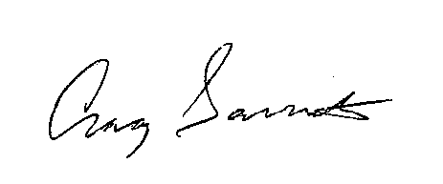

Craig Garriott

P.S. This Sunday, April 23, I will be addressing some of these matters in my message from Acts 2. Again please keep all these matters in prayer. Thank you.

Craig W. Garriott
Pastor, Faith Christian Fellowship
505 E 42nd St
Baltimore, MD 21218
410-323-0202
http://fcfchurch.org/

