Elijah: The manic Depressive prophet pt. 2 1 kings 19:1-18

july 05, 2020

- In James 5:17 we read that “Elijah was a man with a nature like ours…” How does Elijah face some of the same problems that we face today?

- What was Elijah’s response when Jezebel told him that she was going to get him? (1 Kings 19:3)
- Why was Elijah scared?

Have you ever felt scared before? Why is it hard to think clearly when we are scared?

Look at the map, why was Elijah running away from Israel?

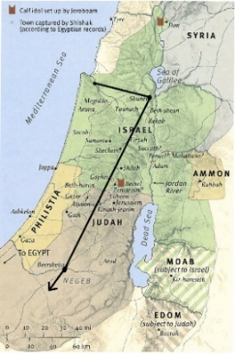

(Elijah’s journey) (A broom tree)

How did The Angel of the Lord help Elijah when he was under the broom tree? (1 Kings 19:5-8)
Why did Elijah feel like he was all alone? (1 Kings 19:10)
Describe how God revealed Himself to Elijah (1 Kings 19:11-13). ____________________________________________________________________________________________________________________________________________________________________________________________________________________________________________________________________________________________________________________________________________________________________________
How did God take Elijah to heaven?
¹¹ And as they still went on and talked, behold, chariots of fire and horses of fire separated the two of them. And Elijah went up by a whirlwind into heaven. 2 Kings 2:11

Kids corner questions:
- What did you learn in today’s message?
- What questions do you still have?
NOTES:
________________________________________________________________________________________________________________________________________________________________________
____________________________________________________________________________________

