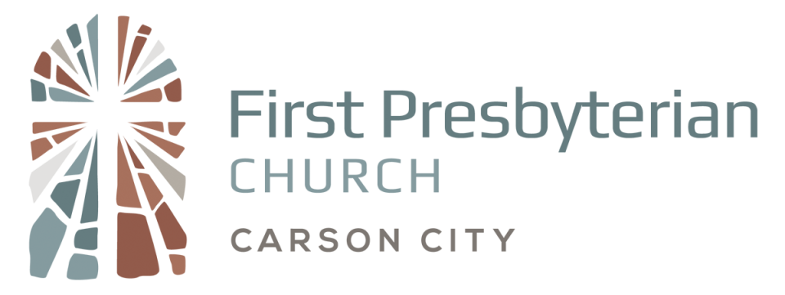

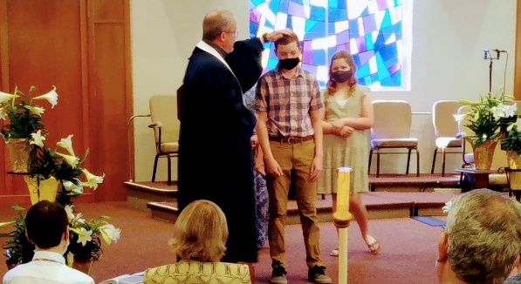
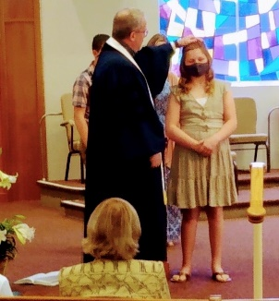
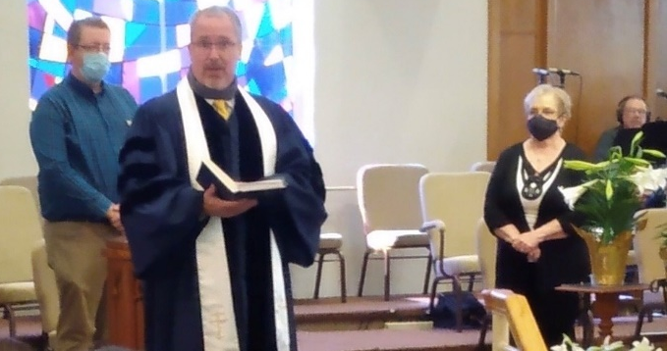

The Body of Christ – New Covenant Partners and Family of God Members! Top: Joe Gurney and Gladyce Jesse / Bottom Taskar Zane and Emma Zane
Sanctuary: 115 N. Division St. Office: 306 W. Musser St.
Carson City, Nevada 89703 Carson City, Nevada 89703
www.fpccarsoncity.org 775.882.1032

Our Mission as God’s people is to daily seek to respond in word and action to Jesus’ great commission: “Go therefore and make disciples of all nations, baptizing them in the name of the Father and of the Son and of the Holy Spirit, and teaching them to obey everything that I have commanded you. And remember, I am with you always, to the end of the age.” Matthew 28:19-20
APRIL 18, 2021
10:00 AM

HOLINESS (TAKE MY LIFE) Underwood
Verse 1
Holiness, holiness
Is what I long for,
Holiness is what I need.
Holiness, holiness
Is what you want from me.

Chorus
Take my heart and form it,
Take my mind transform it,
Take my will conform it,
To Yours, to Yours, Oh Lord.

Verse 2
Righteousness, Righteousness
Is what I long for,
Righteousness is what I need.
Righteousness, Righteousness
Is what you want from me.

Chorus

Verse 3
Faithfulness, Faithfulness
Is what I long for,
Faithfulness is what I need.
Faithfulness, Faithfulness
Is what you want from me.

Chorus, Verse 1

© 1994, 1995 Mercy/Vineyard Publishing/Admin. by Music Services.

Used by Permission.’

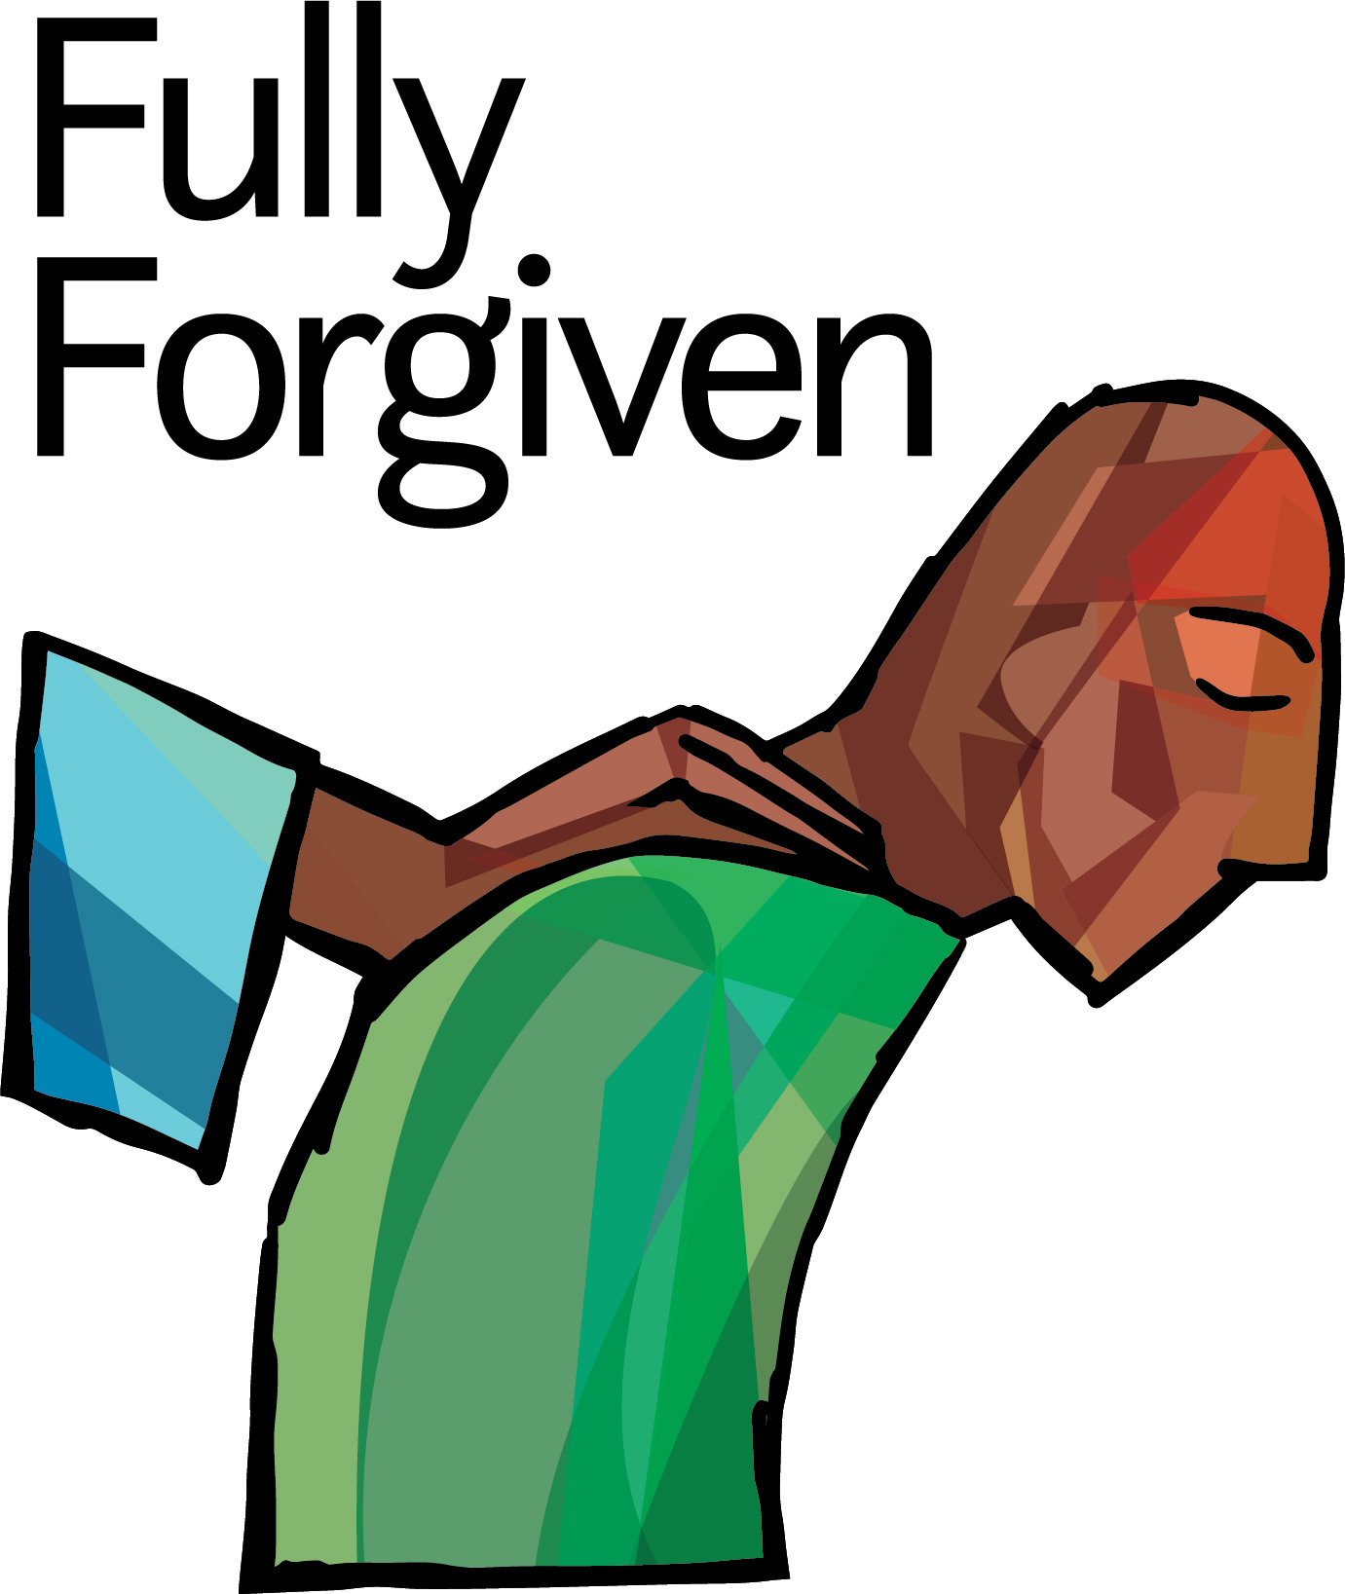
HOW DEEP THE FATHER'S LOVE FOR US
Townend
Verse 1
How deep the Father’s love for us,
How vast beyond all measure
That He should give His only Son
To make a wretch His treasure.
How great the pain of searing loss.
The Father turns His face away
As wounds which mar the Chosen One
Bring many sons to glory.

Verse 2
Behold the Man upon the cross,
My sin upon His shoulders.
Ashamed, I hear my mocking voice
Call out among the scoffers.
It was my sin that held Him there
Until it was accomplished;
His dying breath has brought me life.
I know that it is finished.

Verse 3
I will not boast in anything:
No gifts, no pow’r, no wisdom.
But I will boast in Jesus Christ:
His death and resurrection.
Why should I gain from His reward?
I cannot give an answer.
But this I know with all my heart:
His wounds have paid my ransom.

Why should I gain from His reward?
I cannot give an answer.
But this I know with all my heart:
His wounds have paid my ransom.

CCLI Song #1558110. Copyright © 1995 Thankyou Music (adm. worldwide by EMI/CMG Publishing All rights reserved. Used by permission. Church CCLI License # 1375491

’

Praise Team Music
Church Copyright License #1375491. First Presbyterian Church owns hymnals. Printed for convenience only.

WELCOME TO WORSHIP! We are glad you are here!
Please stand if you are able where the asterisks * appear. Hearing Assist is available at the soundboard. Please silence your cell phones during the service.

Bob Stroh, Liturgist The Rev. Bob Davis, Pastor
Ministers: The Congregation

THE LORD'S DAY CELEBRATION
Father, we come before you today with awe and wonder. We have celebrated your victory and resurrection. We realize how it means that we have been saved by grace through faith in Jesus Christ. We marvel at the depth of your love for your imperfect children. Receive our worship; make it pleasing in your sight. We pray in Jesus’ name. Amen.

WELCOME AND ANNOUNCEMENTS

PRELUDE Prelude on “Guidance” Brackett/Young
Karen Dahlen, Organ

CALL TO WORSHIP God calls us from his word to give him praise.
Psalm 73:21-26 NRSV
“When my soul was embittered, when I was pricked in heart, I was stupid and ignorant; I was like a brute beast toward you . Nevertheless, I am continually with you; you hold my right hand. You guide me with your counsel, and afterward you will receive me with honor. Whom have I in heaven but you? And there is nothing on earth that I desire other than you. My flesh and my heart may fail, but God is the strength of my heart and my portion forever.”

*HYMNS OF PRAISE “He Lives” #220
“Holiness”

“How Deep the Father’s Love for Us”
(Please be seated)
UNISON PRAYER OF CONFESSION We acknowledge our common need for God’s grace.
We praise you, Lord. We have gathered this morning to lift our voices to you, to proclaim your glory, to share of your goodness. Even as we do, God, we are aware of the ways we hold back. We avoid and deny the truth when we are afraid. We often say the words of praise while at the same time disobeying your commands. We confess our sin to you, O God, and ask you to remove it from us. You – and you alone – have provided for our salvation by sending your Son, Jesus Christ, to die for us.

TIME OF PERSONAL SILENT CONFESSION
ASSURANCE OF PARDON We hear from God’s word that we are saved by God’s grace.
“And Can it Be?” #203, verse 2 & refrain
He left His Father’s throne above, so free, so infinite His grace!
Emptied Himself of all but love, and bled for Adam’s helpless race!
‘Tis mercy all, immense and free, for, O my God, it found out me.
Amazing love! How can it be that Hou, my God, shouldst die for me!

CHILDREN GRADES 4th -6th ARE DISMISSED TO SUNDAY SCHOOL

PRAYERS OF THE PEOPLE AND LORD’S PRAYER
Our Father who art in Heaven, hallowed be Thy name;
Thy kingdom come, Thy will be done on earth as it is in heaven.
Give us this day our daily bread, and forgive us our debts, as we forgive our debtors.
And lead us not into temptation but deliver us from evil.
For Thine is the kingdom, and the power, and the glory, forever. Amen.

OFFERTORY WORD & PRESENTATION OF OUR TITHES AND OFFERINGS Elder George Stanton

OFFERTORY “I’d Rather Have Jesus” Miller/Shea/arr. Martin
Chancel Choir

*DOXOLOGY We give God thanks and praise.
Praise God from whom all blessings flow;
Praise Him, all creatures here below;
Praise Him above, ye heav’nly host;
Praise Father, Son and Holy Ghost. Amen.

THE WORD OF GOD READ – NEW TESTAMENT
Mark 14: 66-72
THE WORD OF GOD READ – OLD TESTAMENT
Genesis 12: 10-17

Pastor: This is the word of the Lord.
People: Thanks be to God.

THE WORD OF GOD PROCLAIMED

“Imperfect People” Pastor Bob Davis

*HYMN “Crown Him with Many Crowns” #234

*BENEDICTION

*BENEDICTION RESPONSE We go out in song to proclaim God’s good news in Jesus Christ
“Thine is the Glory” #227, verse 2 & refrain
Lo! Jesus meets us, risen from the tomb;
Lovingly He greets us, scatters fear and gloom
Let His church with gladness hymns of triumph sing,
For her Lord now liveth; death hath lost its sting.
Thine is the glory, Risen, conquering Son;
Endless is the victory Thou o’er death has won.

POSTLUDE “The Solid Rock” Bradbury/arr. Wolaver
Karen Dahlen, Piano

Submit prayer requests to the church office by emailing margo@fpccarsoncity.org or calling Margo at the church office (882-1032 x212). Prayer request cards are also available in the Narthex. Prayer requests will remain on the list for approximately two weeks and can be requested to be renewed.

ON OUR PRAYER LIST Requested as of April 14, 2021

Please pray for these families: Names removed for privacy

Missions and missionaries to pray for: Leo Calva and family in Ecuador as they fight COVID;

Active-Duty Military in Our Prayers: Names removed for privacy

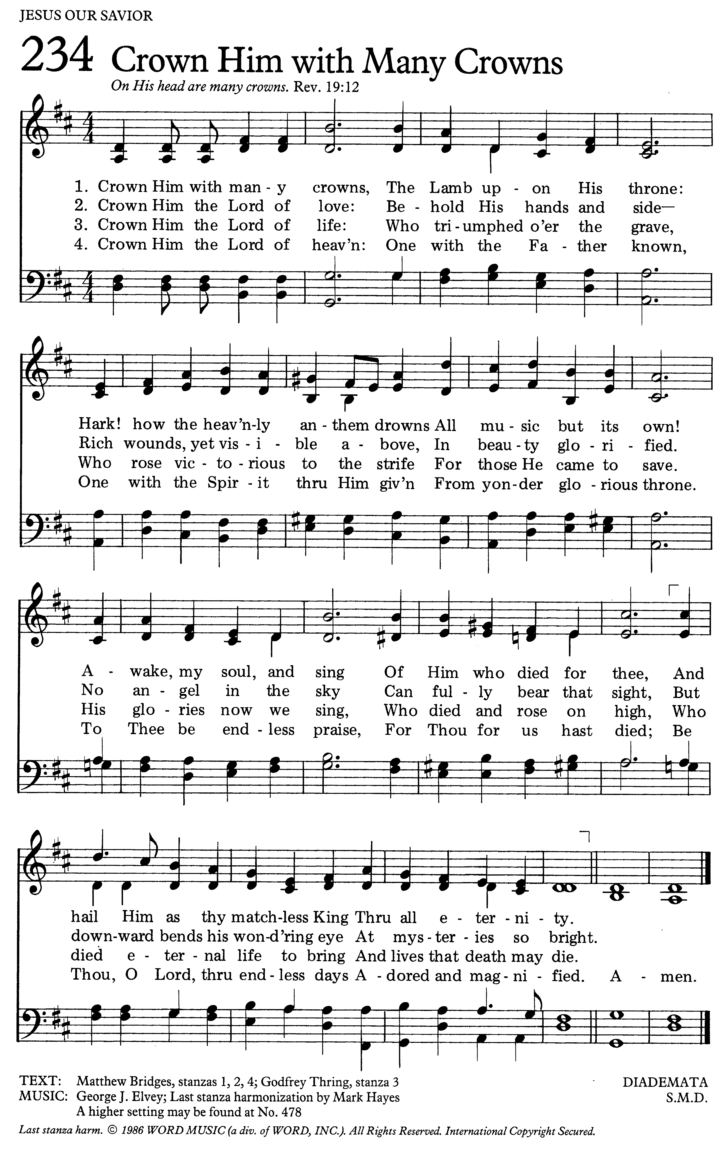
TODAY April 18
10:00 AM Worship Service – seating in Sanctuary & livestream in FLC
Nursery care & Children’s Sunday School Grades 1-3; Grades 4-6 leave from Worship
11:30 AM Youth Work Group (Fellowship Hall)
11:30 AM Fellowship Time in lawn area
MONDAY April 19
11:00 AM Women’s Bible Study (Library)
TUESDAY April 20
8:00 AM SON Rise Women’s Bible Study (contact office for location)
5:30 PM Session Meeting
WEDNESDAY April 21
8:00 AM Men's Study Group (Mallard’s)
9:00 AM Grace Notes Rehearsal
10:00 AM Pastor’s Study (FLC & Zoom)
6:30 PM Pastor’s Study (FLC & Zoom)
7:00 PM Chancel Choir Rehearsal
THURSDAY April 22
8:00 AM Wilson Men's Fellowship (Mallard’s)
FRIDAY (office closed) April 23
SATURDAY April 24
SUNDAY April 25
10:00 AM Worship Service – seating in Sanctuary & livestream in FLC
Nursery care & Children’s Sunday School Grades 1-3; Grades 4-6 leave from Worship
11:30 AM Fellowship Time in lawn area
11:45 AM New Covenant Partner Class (FLC)

To access Sunday Worship at home:
(1) subscribe to our YouTube Channel or
(2) sign up to receive an email from Pastor Bob on Sunday morning just prior to the start of the service. The service can be found at any time after first broadcast on YouTube – search First Presbyterian Church Carson City.

CALLING ALL CHOIR MEMBERS AND SINGERS!!
Chancel Choir has returned to rehearsal on Wednesday nights at 7:00 pm. We rehearse for an hour and a half on Wednesdays and sing every Sunday. Please join us if you are able! Contact Karen Dahlen with any questions at 775-721-3549.

ZEPHYR POINT CONFERENCE CENTER WORKDAY
Saturday, May 8, 2021 8 am – 4 pm
We have scheduled a Spring workday at ZP!
Meet at the Zephyr Point Maintenance Office at 7:30 for coffee and donuts; lunch will be provided by Zephyr Point. Contact Grace or Bob Speicher if you would like to join the work group.

checks, coins, and bills being counted, you all gave - DRUM ROLL PLEASE- $2,530.00 for this mission cause. You are helping women to see that they have good choices with support instead of aborting their precious babies. You also are helping to support the mobile unit that we all got to see and tour.
Thank You from your Mission Committee

Youth Temperance Education Week
April 18-24.
It’s a great time to share with youth of all ages about the dangers of alcohol, drugs, and tobacco and to educate and them to live a life of abstinence free of these dangers. Flyers and information are available in the Narthex. If you would like more information, please contact Susan Kerber Rose.
THIS WEEK ANNOUNCEMENTS

BABY BOTTLE UPDATE
You are an amazing, generous church family. Our goal this year for our Life Choices Baby Bottle Campaign was $3,000. After many
CALLING ALL
CHOIR MEMBERS AND SINGERS

