GRACE LUTHERAN CHAPEL
Grace Chapel exists to make and keep disciples for Jesus Christ.
Eighth Sunday after Pentecost
Saturday, July 17, 2021 - 4:00 p.m.
Sunday, July 18, 2021 – 8:00 a.m.

Welcome to Grace Lutheran Chapel and to our worship with Holy Communion. As Lutheran Christians we believe and confess that Christ’s Body and Blood are present in the bread and wine of Holy Communion. This meal benefits those who acknowledge and confess their sin and trust in Christ alone for their salvation. Where Christ’s true body and blood are present, so also is the forgiveness of sins and eternal life. Baptized and instructed Christians who share in this belief are welcome to this meal of our Lord’s grace and forgiveness.

WELCOME/ANNOUNCEMENTS/GREETING

OPENING HYMN “Savior, like a Shepherd Lead Us,” No. 711
1 Savior, like a shepherd lead us; Much we need Your tender care.
In Your pleasant pastures feed us, For our use Your fold prepare.
Blessèd Jesus, blessèd Jesus, You have bought us; we are Yours.
Blessèd Jesus, blessèd Jesus, You have bought us; we are Yours.

2 We are Yours; in love befriend us, Be the guardian of our way;
Keep Your flock, from sin defend us, Seek us when we go astray.
Blessèd Jesus, blessèd Jesus, Hear us children when we pray.
Blessèd Jesus, blessèd Jesus, Hear us children when we pray.

3 You have promised to receive us, Poor and sinful though we be;
You have mercy to relieve us, Grace to cleanse, and pow’r to free.
Blessèd Jesus, blessèd Jesus, Early let us turn to You.
Blessèd Jesus, blessèd Jesus, Early let us turn to You.

4 Early let us seek Your favor, Early let us do Your will;
Blessèd Lord and only Savior, With Your love our spirits fill.
Blessèd Jesus, blessèd Jesus, You have loved us, love us still.
Blessèd Jesus, blessèd Jesus, You have loved us, love us still.

LITURGY - Divine Service 4, p. 203 in Lutheran Service Book (please stand)

INVOCATION
In the name of the Father and of the + Son and of the Holy Spirit.
Amen.

EXHORTATION
Our help is in the name of the Lord,
who made heaven and earth.

If You, O Lord, kept a record of sins, O Lord, who could stand?
But with You there is forgiveness; therefore You are feared.

Since we are gathered to hear God’s Word, call upon Him in prayer and praise, and receive the body and blood of our Lord Jesus Christ in the fellowship of this altar, let us first consider our unworthiness and confess before God and one another that we have sinned in thought, word, and deed, and that we cannot free ourselves from our sinful condition. Together as His people let us take refuge in the infinite mercy of God, our heavenly Father, seeking His grace for the sake of Christ, and saying: God, be merciful to me, a sinner.

CONFESSION AND ABSOLUTION
Almighty God, have mercy upon us, forgive us our sins, and lead us to everlasting life. Amen.
Almighty God in His mercy has given His Son to die for you and for His sake forgives you all your sins. As a called and ordained servant of Christ, and by His authority, I therefore forgive you all your sins in the name of the Father and of the + Son and of the Holy Spirit.
Amen.

HYMN OF PRAISE - “Gloria In Excelsis” p. 204
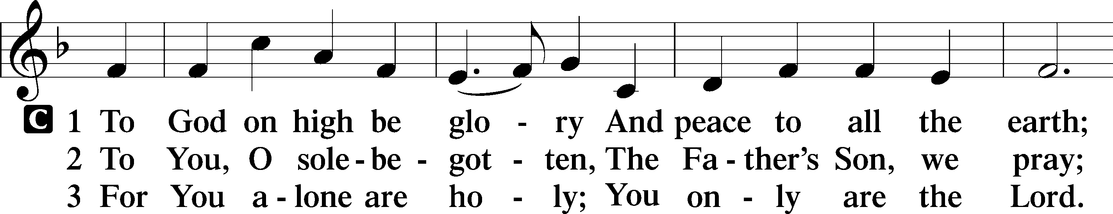

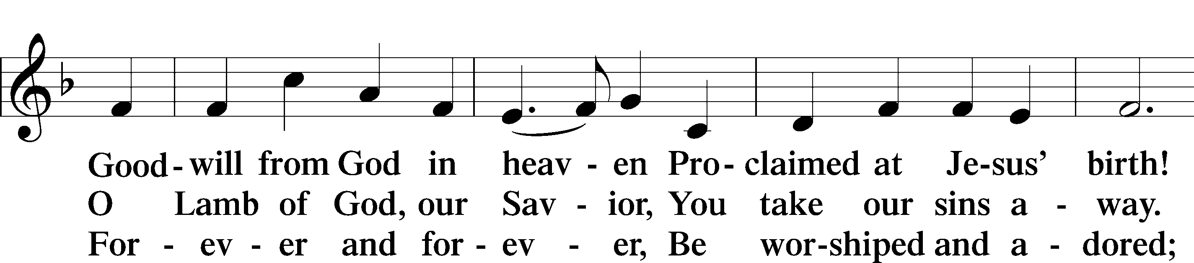

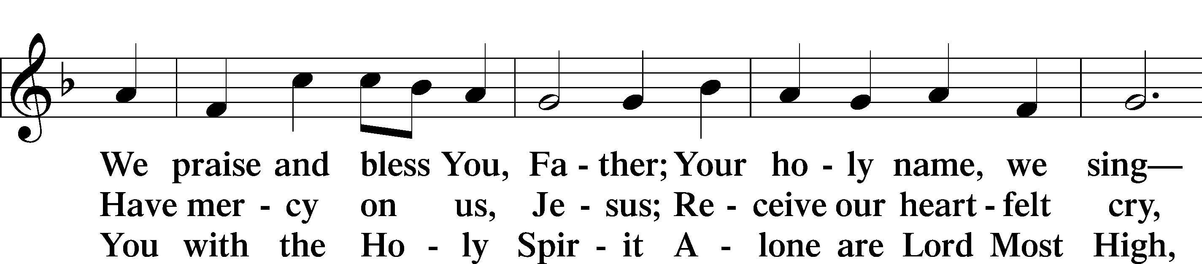

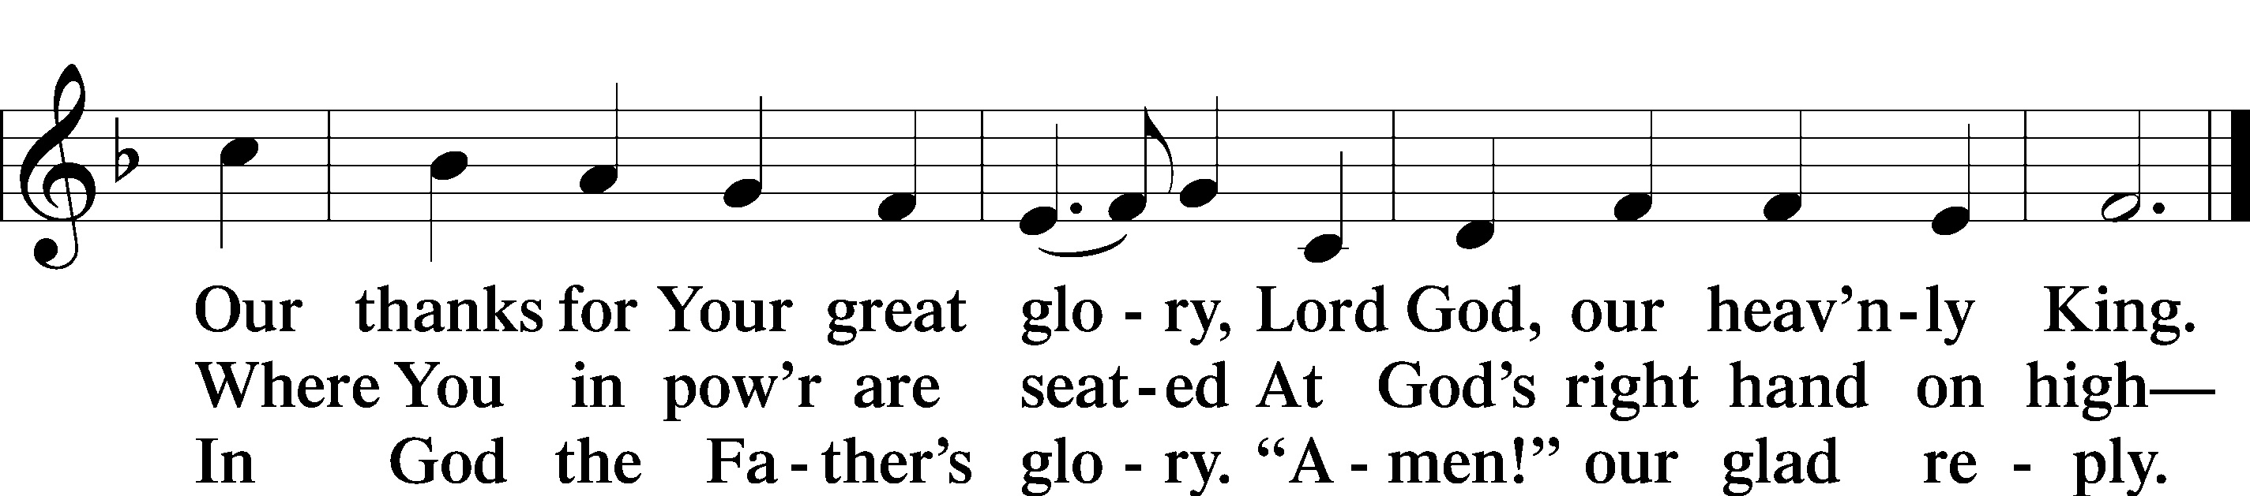

SALUTATION
The Lord be with you.
And also with you.

PRAYER OF THE DAY
Let us pray. Blessed are You, O Lord our God, King of the universe, for You have not abandoned Your creation but have sent Your Son to be our Shepherd and our righteousness. Give us the strength of faith to follow Him who calls us by name that we may dwell in safety as Your redeemed people now and forever; through the same Jesus Christ, our Lord, and our eternal King, who lives and reigns with You and the Holy Spirit, one God, now and forever.
Amen.

OLD TESTAMENT READING Jeremiah 23:1-6
“Woe to the shepherds who destroy and scatter the sheep of my pasture!” declares the Lord.
² Therefore thus says the Lord, the God of Israel, concerning the shepherds who care for my people: “You have scattered my flock and have driven them away, and you have not attended to them. Behold, I will attend to you for your evil deeds, declares the Lord. ³ Then I will gather the remnant of my flock out of all the countries where I have driven them, and I will bring them back to their fold, and they shall be fruitful and multiply. ⁴ I will set shepherds over them who will care for them, and they shall fear no more, nor be dismayed, neither shall any be missing, declares the Lord.
⁵ “Behold, the days are coming, declares the Lord, when I will raise up for David a righteous Branch, and he shall reign as king and deal wisely, and shall execute justice and righteousness in the land. ⁶ In his days Judah will be saved, and Israel will dwell securely. And this is the name by which he will be called: ‘The Lord is our righteousness.’

This is the Word of the Lord. Thanks be to God.

EPISTLE Ephesians 2:11-22
¹¹ Therefore remember that at one time you Gentiles in the flesh, called “the uncircumcision” by what is called the circumcision, which is made in the flesh by hands— ¹² remember that you were at that time separated from Christ, alienated from the commonwealth of Israel and strangers to the covenants of promise, having no hope and without God in the world. ¹³ But now in Christ Jesus you who once were far off have been brought near by the blood of Christ. ¹⁴ For he himself is our peace, who has made us both one and has broken down in his flesh the dividing wall of hostility ¹⁵ by abolishing the law of commandments expressed in ordinances, that he might create in himself one new man in place of the two, so making peace, ¹⁶ and might reconcile us both to God in one body through the cross, thereby killing the hostility. ¹⁷ And he came and preached peace to you who were far off and peace to those who were near. ¹⁸ For through him we both have access in one Spirit to the Father. ¹⁹ So then you are no longer strangers and aliens, but you are fellow citizens with the saints and members of the household of God, ²⁰ built on the foundation of the apostles and prophets, Christ Jesus himself being the cornerstone, ²¹ in whom the whole structure, being joined together, grows into a holy temple in the Lord. ²² In him you also are being built together into a dwelling place for God by the Spirit.

This is the Word of the Lord. Thanks be to God.

HOLY GOSPEL Mark 6:30-44
The Holy Gospel according to St. Mark, the sixth chapter.
Glory to You, O Lord.

³⁰ The apostles returned to Jesus and told him all that they had done and taught. ³¹ And he said to them, “Come away by yourselves to a desolate place and rest a while.” For many were coming and going, and they had no leisure even to eat. ³² And they went away in the boat to a desolate place by themselves. ³³ Now many saw them going and recognized them, and they ran there on foot from all the towns and got there ahead of them. ³⁴ When he went ashore he saw a great crowd, and he had compassion on them, because they were like sheep without a shepherd. And he began to teach them many things. ³⁵ And when it grew late, his disciples came to him and said, “This is a desolate place, and the hour is now late. ³⁶ Send them away to go into the surrounding countryside and villages and buy themselves something to eat.” ³⁷ But he answered them, “You give them something to eat.” And they said to him, “Shall we go and buy two hundred denarii worth of bread and give it to them to eat?” ³⁸ And he said to them, “How many loaves do you have? Go and see.” And when they had found out, they said, “Five, and two fish.” ³⁹ Then he commanded them all to sit down in groups on the green grass. ⁴⁰ So they sat down in groups, by hundreds and by fifties. ⁴¹ And taking the five loaves and the two fish, he looked up to heaven and said a blessing and broke the loaves and gave them to the disciples to set before the people. And he divided the two fish among them all. ⁴² And they all ate and were satisfied. ⁴³ And they took up twelve baskets full of broken pieces and of the fish. ⁴⁴ And those who ate the loaves were five thousand men.

This is the Gospel of the Lord. Praise to You, O Christ.

NICENE CREED, p. 206
I believe in one God, the Father Almighty, maker of heaven and earth and of all things visible and invisible.
And in one Lord Jesus Christ, the only-begotten Son of God, begotten of his Father before all worlds, God of God, Light of Light, very God of very God, begotten, not made, being of one substance with the Father, by whom all things were made; who for us men and for our salvation came down from heaven and was incarnate by the Holy Spirit of the virgin Mary and was made man; and was crucified also for us under Pontius Pilate. He suffered and was buried. And the third day he rose again according to the Scriptures and ascended into heaven and sits at the right hand of the Father. And he will come again with glory to judge both the living and the dead, whose kingdom will have no end.
And I believe in the Holy Spirit, the Lord and giver of life, who proceeds from the Father and the Son, who with the Father and the Son together is worshiped and glorified, who spoke by the prophets. And I believe in one holy Christian and apostolic Church, I acknowledge one Baptism for the remission of sins, and I look for the resurrection of the dead and the life of the world to come. Amen.

OFFERING PRAYER

SERMON “A Second Good Shepherd Sunday
Ephesians 2:11-22 – Pastor Eric Stacy

SERMON HYMN “Christ Be My Leader,” No. 861
1 Christ be my Leader by night as by day;
Safe through the darkness, for He is the way.
Gladly I follow, my future His care,
Darkness is daylight when Jesus is there.

2 Christ be my Teacher in age as in youth,
Drifting or doubting, for He is the truth.
Grant me to trust Him; though shifting as sand,
Doubt cannot daunt me; in Jesus I stand.

3 Christ be my Savior in calm as in strife;
Death cannot hold me, for He is the life.
Nor darkness nor doubting nor sin and its stain
Can touch my salvation: with Jesus I reign.
Text: © 1964, renewed 1992 Hope Publishing Co.
Used by permission: LSB Hymn License no. 110003490

PRAYER OF THE CHURCH
Let us pray for the whole people of God in Christ Jesus, and for all people according to their needs.
Blessed are You, O Lord our God, King of the universe, who has sanctified us with Your Word—Your Holy Commandments, Your Holy Scriptures, but above all, with Your Holy Word made flesh, Your only-begotten Son to be our Good Shepherd, our Savior, our Lord, and our King. Receive our praise for the gift of Your salvation and life. Lord, in Your mercy,
hear our prayer.

Blessed are You, O Lord our God, King of the universe, for You have commanded us to pray. Grant Your Holy Church peace and strength to give witness to Your mercy for all people. Bless our nation with faithful leaders who will govern according to Your will in righteousness. Sustain all who protect and defend us from harm and danger both in the world and in Your gift of faith. Lord, in Your mercy,
hear our prayer.

Endow Your ministers with compassion and grace to reach the lost and to serve Your people faithfully with Your Word and Sacraments. Guard and protect them from the assaults of the devil and all enemies of Your Word. Lord, in Your mercy,
hear our prayer.

Deliver and heal all who are in trouble, danger, or illness. Like a shepherd, lead us all to the still waters and green pastures of Your grace. Lord, in Your mercy,
hear our prayer.

Into Your hands, O Lord, we commend all for whom we pray, trusting in Your mercy; through Your Son, Jesus Christ, our Lord.
Amen.

LORD’S PRAYER, p. 209
Our Father, who art in heaven, hallowed be thy name, thy kingdom come, thy will be done on earth as it is in heaven. Give us this day our daily bread; and forgive us our trespasses, as we forgive those who trespass against us; and lead us not into temptation, but deliver us from evil. For thine is the kingdom and the power and the glory forever and ever. Amen.

WORDS OF OUR LORD, p. 162
Our Lord Jesus Christ, on the night when He was betrayed, took bread, and when He had given thanks, He broke it and gave it to the disciples and said: “Take, eat; this is My + body, which is given for you. This do in remembrance of Me.”
In the same way also He took the cup after supper, and when He had given thanks, He gave it to them, saying: “Drink of it, all of you; this cup is the new testament in My + blood, which is shed for you for the forgiveness of sins. This do, as often as you drink it, in remembrance of Me.”

PAX DOMINI, p. 210
The peace of the Lord be with you always.
Amen.
DISTRIBUTION
Distribution Hymns:

“O Living Bread from Heaven,” No. 642
1 O living Bread from heaven, How well You feed your guest!
The gifts that You have given Have filled my heart with rest.
Oh, wondrous food of blessing, Oh, cup that heals our woes!
My heart, this gift possessing, With praises overflows.

2 My Lord, You here have led me To this most holy place
And with Yourself have fed me The treasures of Your grace;
For You have freely given What earth could never buy,
The bread of life from heaven, That now I shall not die.

3 You gave me all I wanted; This food can death destroy.
And You have freely granted The cup of endless joy.
My Lord, I do not merit The favor You have shown,
And all my soul and spirit Bow down before Your throne.

4 Lord, grant me then, thus strengthened With heav’nly food, while here
My course on earth is lengthened, To serve with holy fear.
And when You call my spirit To leave this world below,
I enter, through Your merit, Where joys unmingled flow.

“The Church’s One Foundation,” No. 644
1 The Church’s one foundation Is Jesus Christ, her Lord;
She is His new creation By water and the Word.
From heav’n He came and sought her To be His holy bride;
With His own blood He bought her, And for her life He died.

2 Elect from ev’ry nation, Yet one o’er all the earth;
Her charter of salvation: One Lord, one faith, one birth.
One holy name she blesses, Partakes one holy food,
And to one hope she presses With ev’ry grace endued.

3 Though with a scornful wonder The world sees her oppressed,
By schisms rent asunder, By heresies distressed,
Yet saints their watch are keeping; Their cry goes up, “How long?”
And soon the night of weeping Shall be the morn of song.

4 Through toil and tribulation And tumult of her war
She waits the consummation Of peace forevermore
Till with the vision glorious Her longing eyes are blest,
And the great Church victorious Shall be the Church at rest.

5 Yet she on earth has union With God, the Three in One,
And mystic sweet communion With those whose rest is won.
O blessèd heav’nly chorus! Lord, save us by Your grace
That we, like saints before us, May see You face to face.

“Lord Jesus Christ, Life-Giving Bread,” No. 625
1 Lord Jesus Christ, life-giving bread,
May I in grace possess You.
Let me with holy food be fed,
In hunger I address You.
Prepare me well for You, O Lord,
And, humbly by my prayer implored,
Give me Your grace and mercy.

2 To pastures green, Lord, safely guide,
To restful waters lead me;
Your table well for me provide,
Your wounded hand now feed me.
Though weary, sinful, sick, and weak,
Refuge in You alone I seek,
To share Your cup of healing.

3 O bread of heav’n, my soul’s delight,
For full and free remission
I come with prayer before Your sight
In sorrow and contrition.
Your righteousness, Lord, cover me
That I receive You worthily,
Assured of Your full pardon.

4 I do not merit favor, Lord,
My weight of sin would break me;
In all my guilty heart’s discord,
O Lord, do not forsake me.
In my distress this comforts me
That You receive me graciously,
O Christ, my Lord of mercy!
DISMISSAL BLESSING, p. 210
The body and blood of our Lord Jesus Christ strengthen and preserve you in body and soul to life everlasting. Depart + in peace.
Amen.

POST-COMMUNION COLLECT, p. 212
We give thanks to You, almighty God, that You have refreshed us through this salutary gift, and we implore You that of Your mercy You would strengthen us through the same in faith toward You and fervent love toward one another; through Jesus Christ, Your Son, our Lord, who lives and reigns with You and the Holy Spirit, one God, now and forever.
Amen.

BENEDICTION
The Lord bless you and keep you.
The Lord make His face shine on you and be gracious to you.
The Lord look upon you with favor and + give you peace.
Amen.

CLOSING HYMN “Lord, Dismiss Us with Your Blessing,” No. 924
1 Lord, dismiss us with Your blessing, Fill our hearts with joy and peace;
Let us each, Your love possessing, Triumph in redeeming grace.
O refresh us; O refresh us, Trav’ling through this wilderness.

2 Thanks we give and adoration For Your Gospel’s joyful sound.
May the fruits of Your salvation In our hearts and lives abound.
Ever faithful, ever faithful To Your truth may we be found.

3 Savior, when Your love shall call us From our struggling pilgrim way,
Let not fear of death appall us, Glad Your summons to obey.
May we ever, may we ever Reign with You in endless day.

POSTLUDE

Grace is for all!

