GRACE LUTHERAN CHAPEL
Grace Chapel exists to make and keep disciples for Jesus Christ.

Seventh Sunday after Pentecost
Saturday, July 18, 2020 - 4:00 p.m.
Sunday, July 19, 2020 - 8:00 a.m.

Welcome to Grace Lutheran Chapel and to our worship with Holy Communion. As Lutheran Christians we believe and confess that Christ’s Body and Blood are present in the bread and wine of Holy Communion. This meal benefits those who acknowledge and confess their sin and trust in Christ alone for their salvation. Where Christ’s true body and blood are present, so also is the forgiveness of sins and eternal life. Baptized and instructed Christians who share in this belief are welcome to this meal of our Lord’s grace and forgiveness.

WELCOME/ANNOUNCEMENTS/GREETING

OPENING HYMN “Great Is Thy Faithfulness” No. 809
1 Great is Thy faithfulness, O God my Father;
There is no shadow of turning with Thee.
Thou changest not: Thy compassions, they fail not;
As Thou hast been, Thou forever wilt be. Refrain

Refrain: Great is Thy faithfulness! Great is Thy faithfulness!
Morning by morning new mercies I see;
All I have needed Thy hand hath provided;
Great is Thy faithfulness, Lord, unto me!

2 Summer and winter and springtime and harvest,
Sun, moon, and stars in their courses above
Join with all nature in manifold witness
To Thy great faithfulness, mercy, and love. Refrain

3 Pardon for sin and a peace that endureth,
Thine own dear presence to cheer and to guide;
Strength for today and bright hope for tomorrow,
Blessings all mine, with ten thousand beside! Refrain

LITURGY - Divine Service 4, p. 203 in Lutheran Service Book (please stand)

INVOCATION
In the name of the Father and of the + Son and of the Holy Spirit.
Amen.

EXHORTATION
Our help is in the name of the Lord,
who made heaven and earth.

If You, O Lord, kept a record of sins, O Lord, who could stand?
But with You there is forgiveness; therefore You are feared.

Since we are gathered to hear God’s Word, call upon Him in prayer and praise, and receive the body and blood of our Lord Jesus Christ in the fellowship of this altar, let us first consider our unworthiness and confess before God and one another that we have sinned in thought, word, and deed, and that we cannot free ourselves from our sinful condition. Together as His people let us take refuge in the infinite mercy of God, our heavenly Father, seeking His grace for the sake of Christ, and saying: God, be merciful to me, a sinner.

CONFESSION OF SINS
Almighty God, have mercy upon us, forgive us our sins, and lead us to everlasting life. Amen.

ABSOLUTION
Almighty God in His mercy has given His Son to die for you and for His sake forgives you all your sins. As a called and ordained servant of Christ, and by His authority, I therefore forgive you all your sins in the name of the Father and of the + Son and of the Holy Spirit.
Amen.

HYMN OF PRAISE - “Gloria In Excelsis” p. 204
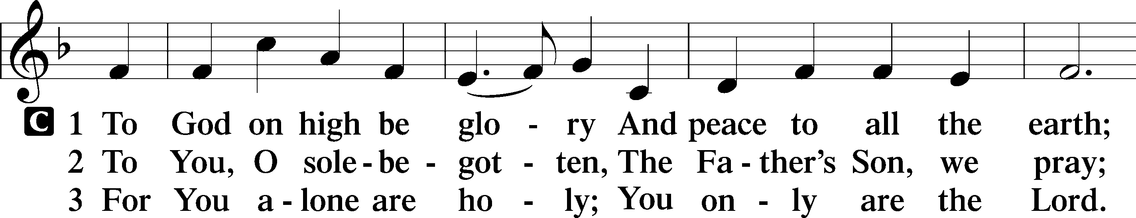

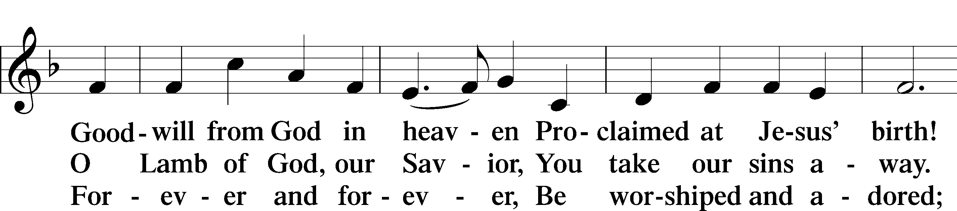

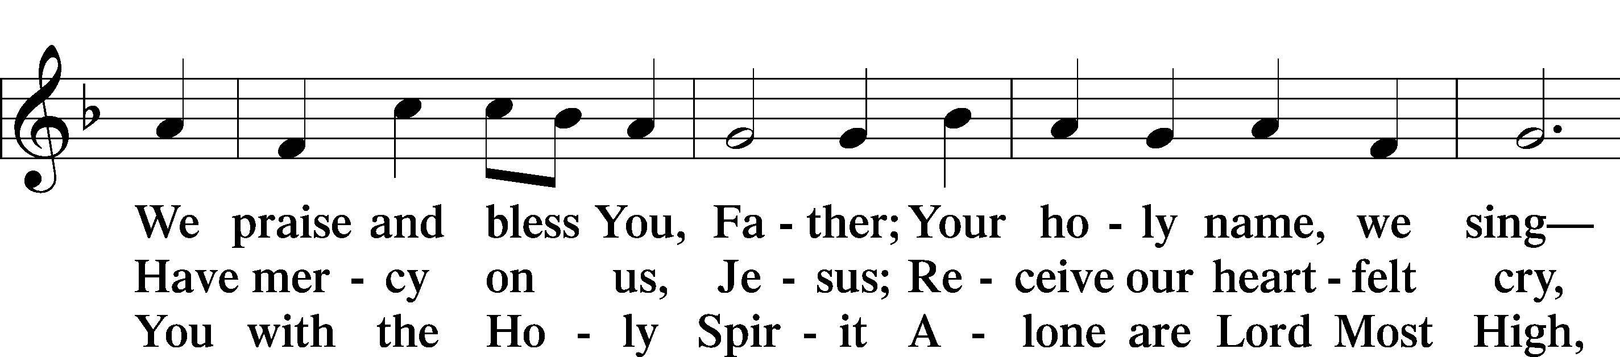

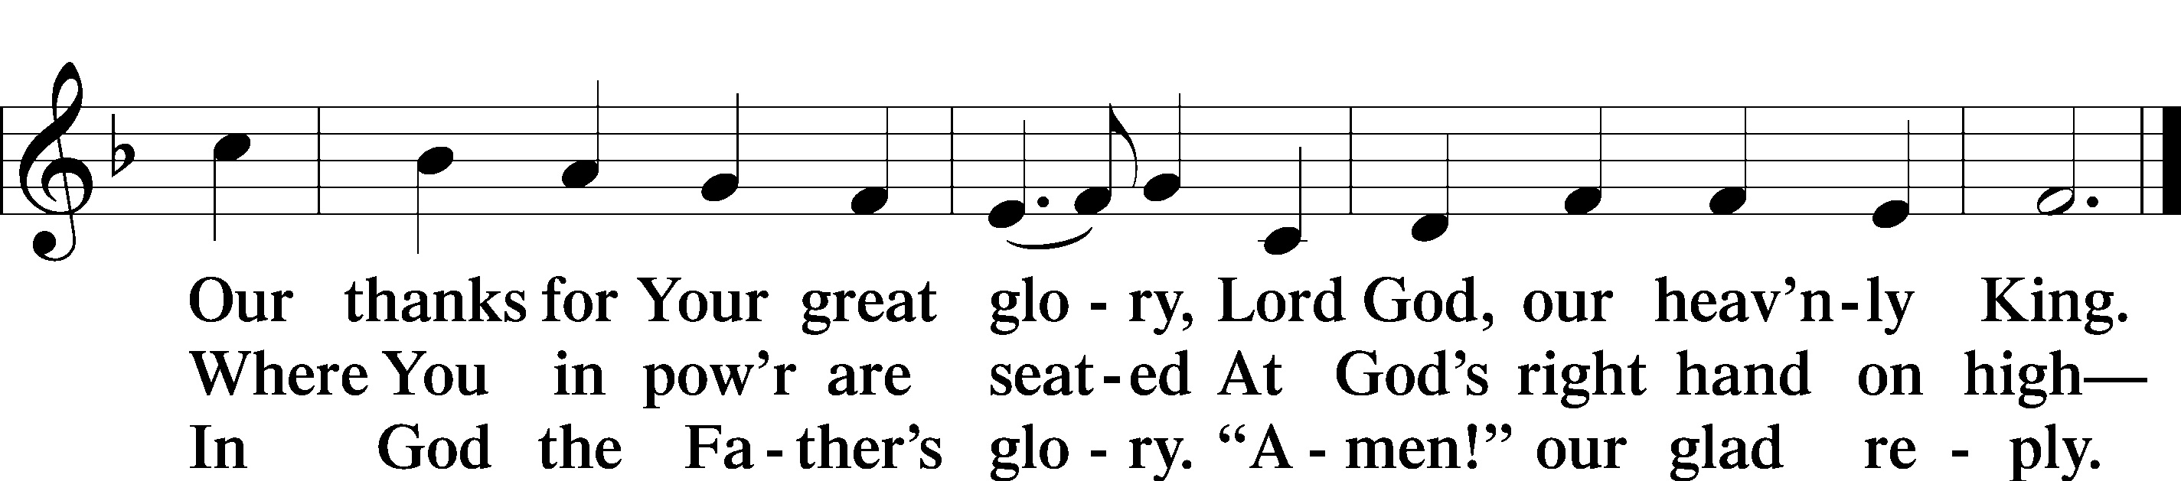

SALUTATION
The Lord be with you.
And also with you.

PRAYER OF THE DAY
Let us pray. O steadfast Lord, You are the great I am whose promises never fail us and in whom alone salvation is to be found. Grant to us hearts to trust in Your mercy and courage in the face of doubt and fear that we not surrender hope to darkness and faith to unbelief; through Jesus Christ, Your Son, our Lord, who lives and reigns with You and the Holy Spirit, one God, now and forever.
Amen.

OLD TESTAMENT READING Isaiah 44:6-8
⁶ Thus says the Lord, the King of Israel and his Redeemer, the Lord of hosts: “I am the first and I am the last; besides me there is no god. ⁷ Who is like me? Let him proclaim it. Let him declare and set it before me, since I appointed an ancient people. Let them declare what is to come, and what will happen.⁸ Fear not, nor be afraid; have I not told you from of old and declared it? And you are my witnesses! Is there a God besides me? There is no Rock; I know not any.”

This is the Word of the Lord. Thanks be to God.

EPISTLE Romans 8:18-27
¹⁸ For I consider that the sufferings of this present time are not worth comparing with the glory that is to be revealed to us. ¹⁹ For the creation waits with eager longing for the revealing of the sons of God. ²⁰ For the creation was subjected to futility, not willingly, but because of him who subjected it, in hope ²¹ that the creation itself will be set free from its bondage to corruption and obtain the freedom of the glory of the children of God. ²² For we know that the whole creation has been groaning together in the pains of childbirth until now. ²³ And not only the creation, but we ourselves, who have the firstfruits of the Spirit, groan inwardly as we wait eagerly for adoption as sons, the redemption of our bodies. ²⁴ For in this hope we were saved. Now hope that is seen is not hope. For who hopes for what he sees? ²⁵ But if we hope for what we do not see, we wait for it with patience.
²⁶ Likewise the Spirit helps us in our weakness. For we do not know what to pray for as we ought, but the Spirit himself intercedes for us with groanings too deep for words. ²⁷ And he who searches hearts knows what is the mind of the Spirit, because the Spirit intercedes for the saints according to the will of God.

This is the Word of the Lord. Thanks be to God.

HOLY GOSPEL Matthew 13:24-30, 36-43
The Holy Gospel according to St. Matthew, the thirteenth chapter.
Glory to You, O Lord.

⁴ He put another parable before them, saying, “The kingdom of heaven may be compared to a man who sowed good seed in his field, ²⁵ but while his men were sleeping, his enemy came and sowed weeds among the wheat and went away. ²⁶ So when the plants came up and bore grain, then the weeds appeared also. ²⁷ And the servants^{[b]} of the master of the house came and said to him, ‘Master, did you not sow good seed in your field? How then does it have weeds?’ ²⁸ He said to them, ‘An enemy has done this.’ So the servants said to him, ‘Then do you want us to go and gather them?’ ²⁹ But he said, ‘No, lest in gathering the weeds you root up the wheat along with them. ³⁰ Let both grow together until the harvest, and at harvest time I will tell the reapers, “Gather the weeds first and bind them in bundles to be burned, but gather the wheat into my barn.”’”
³⁶ Then he left the crowds and went into the house. And his disciples came to him, saying, “Explain to us the parable of the weeds of the field.” ³⁷ He answered, “The one who sows the good seed is the Son of Man. ³⁸ The field is the world, and the good seed is the sons of the kingdom. The weeds are the sons of the evil one, ³⁹ and the enemy who sowed them is the devil. The harvest is the end of the age, and the reapers are angels. ⁴⁰ Just as the weeds are gathered and burned with fire, so will it be at the end of the age. ⁴¹ The Son of Man will send his angels, and they will gather out of his kingdom all causes of sin and all law-breakers, ⁴² and throw them into the fiery furnace. In that place there will be weeping and gnashing of teeth. ⁴³ Then the righteous will shine like the sun in the kingdom of their Father. He who has ears, let him hear.

This is the Gospel of the Lord. Praise to You, O Christ.

NICENE CREED, p. 206
I believe in one God, the Father Almighty, maker of heaven and earth and of all things visible and invisible.
And in one Lord Jesus Christ, the only-begotten Son of God, begotten of his Father before all worlds, God of God, Light of Light, very God of very God, begotten, not made, being of one substance with the Father, by whom all things were made; who for us men and for our salvation came down from heaven and was incarnate by the Holy Spirit of the virgin Mary and was made man; and was crucified also for us under Pontius Pilate. He suffered and was buried. And the third day he rose again according to the Scriptures and ascended into heaven and sits at the right hand of the Father. And he will come again with glory to judge both the living and the dead, whose kingdom will have no end.
And I believe in the Holy Spirit, the Lord and giver of life, who proceeds from the Father and the Son, who with the Father and the Son together is worshiped and glorified, who spoke by the prophets. And I believe in one holy Christian and apostolic Church, I acknowledge one Baptism for the remission of sins, and I look for the resurrection of the dead and the life of the world to come. Amen.

OFFERING PRAYER

SERMON “From Groaning to Glory, Even Now”
Romans 8:18-27 – Dr. Glenn Nielsen

SERMON HYMN "Creator of the Stars of Night” No. 351
1 Creator of the stars of night, Thy people’s everlasting Light:
O Christ, Redeemer, save us all And hear Thy servants when they call.

2 Thou, grieving that the ancient curse Should doom to death a universe,
Hast found the healing, full of grace, To cure and save our ruined race.

3 Thou cam’st the Bridegroom of the bride, As drew the world to eventide,
The spotless Victim all divine Proceeding from a virgin shrine.

4 At whose dread name, majestic now, All knees must bend, all hearts must bow;
All things celestial Thee shall own, And things terrestrial, Lord alone.

5 O Thou, whose coming is with dread To judge the living and the dead,
Preserve us from the ancient foe While still we dwell on earth below.

6 To God the Father and the Son And Holy Spirit, Three in One,
Praise, honor, might, and glory be From age to age eternally. Amen.

PRAYER OF THE CHURCH
Let us pray for the whole people of God in Christ Jesus and for all people according to their needs.
Lord, You have been the refuge and strength of Your people from generation to generation. Give to us the comfort of Your presence in time of trouble, Your grace to forgive our sins, and Your peace to govern our hearts. Lord, in Your mercy,
hear our prayer.

Lord, Your power holds all things together, in heaven and on earth. Give wisdom to those who lead our nation and guidance to those who make, administer, and judge our laws, so that life be protected and justice administered. Lord, in Your mercy,
hear our prayer.

Lord, Your Word speaks hope and life. Open our ears to hear Your voice and our hearts to believe in Jesus Christ and follow Him as Savior and Lord. Lord, in Your mercy,
hear our prayer.

Lord, Your Church lives by the grace You bestow through Word and Sacrament. Bless the pastors who preach to us this Gospel and the church workers who serve us in Your name. Lord, in Your mercy,
hear our prayer.

Lord, Your mercy extends to all our needs and Your grace gives healing according to Your will. Hear us on behalf of all who stand in need. Grant to them grace sufficient for all their needs and sustain them in the hour of trial. Lord, in Your mercy,
hear our prayer.

Lord, You give us new lives in baptismal water, and Your Spirit opens our hearts to faith. Help us to live out fully our vocation as Your children in the places where we live and work and do the good works You desire. Lord, in Your mercy,
hear our prayer.

Lord, You have granted us a place at the Table of Your Son. Help us to receive His body and blood with repentance and faith and to keep in holy lives the precious gift we will receive upon our lips. Lord, in Your mercy,
hear our prayer.

Lord, You have given us the encouragement of the mighty saints of old and those who taught us the faith. Help us to leave a legacy of faithfulness to those who follow us, and sustain us in hope until we join the saints in Christ’s eternal presence. Lord, in Your mercy,
hear our prayer.

Into Your hands, O Lord, we commend ourselves and all for whom we pray, trusting in Your mercy, through Your Son, Jesus Christ, our Lord.
Amen.

LORD’S PRAYER, p. 209
Our Father, who art in heaven, hallowed be thy name, thy kingdom come, thy will be done on earth as it is in heaven. Give us this day our daily bread; and forgive us our trespasses, as we forgive those who trespass against us; and lead us not into temptation, but deliver us from evil. For thine is the kingdom and the power and the glory forever and ever. Amen.

WORDS OF OUR LORD, p. 162
Our Lord Jesus Christ, on the night when He was betrayed, took bread, and when He had given thanks, He broke it and gave it to the disciples and said: “Take, eat; this is My + body, which is given for you. This do in remembrance of Me.”
In the same way also He took the cup after supper, and when He had given thanks, He gave it to them, saying: “Drink of it, all of you; this cup is the new testament in My + blood, which is shed for you for the forgiveness of sins. This do, as often as you drink it, in remembrance of Me.”

PAX DOMINI, p. 210
The peace of the Lord be with you always.
Amen.

DISMISSAL BLESSING, p. 210
The body and blood of our Lord Jesus Christ strengthen and preserve you in body and soul to life everlasting. Depart + in peace.
Amen.

BENEDICTION
The Lord bless you and keep you.
The Lord make His face shine on you and be gracious to you.
The Lord look upon you with favor and + give you peace.
Amen.

DISTRIBUTION DURING SINGING OF THE CLOSING HYMN

CLOSING HYMN “The Lord, My God, Be Praised” No. 794
1 The Lord, my God, be praised, My light, my life from heaven;
My maker, who to me Has soul and body given;
My Father, who will shield And keep me day by day
And make each moment yield New blessings on my way.

2 The Lord, my God, be praised, My trust, my life from heaven,
The Father’s own dear Son, Whose life for me was given,
Who for my sin atoned With His most precious blood
And gives to me by faith The highest heav’nly good.

3 The Lord, my God, be praised, My hope, my life from heaven,
The Spirit, whom the Son In love to me has given.
His grace revives my heart And gives my spirit pow’r,
Help, comfort, and support In sorrow’s gloomy hour.

4 The Lord, my God, be praised, My God, the ever-living,
To whom the heav’nly host Their laud and praise are giving.
The Lord, my God, be praised, In whose great name I boast,
God Father, God the Son, And God the Holy Ghost.

POSTLUDE

Grace is for all

