GRACE LUTHERAN CHAPEL
Grace Chapel exists to make and keep disciples for Jesus Christ.
Seventh Sunday of Easter
Saturday, May 15, 2021 - 4:00 p.m.
Sunday, May 16, 2021 – 8:00 a.m.

Welcome to Grace Lutheran Chapel and to our worship with Holy Communion. As Lutheran Christians we believe and confess that Christ’s Body and Blood are present in the bread and wine of Holy Communion. This meal benefits those who acknowledge and confess their sin and trust in Christ alone for their salvation. Where Christ’s true body and blood are present, so also is the forgiveness of sins and eternal life. Baptized and instructed Christians who share in this belief are welcome to this meal of our Lord’s grace and forgiveness.

WELCOME/ANNOUNCEMENTS/GREETING

ANNIVERSARY RECOGNITIONS (8:00 a.m.)

OPENING HYMN “Alleluia! Sing to Jesus,” No. 821
1 Alleluia! Sing to Jesus; His the scepter, His the throne;
Alleluia! His the triumph, His the victory alone.
Hark! The songs of peaceful Zion Thunder like a mighty flood:
“Jesus out of ev’ry nation Has redeemed us by His blood.

2 Alleluia! Not as orphans Are we left in sorrow now;
Alleluia! He is near us; Faith believes, nor questions how.
Though the cloud from sight received Him When the forty days were o’er,
Shall our hearts forget His promise: “I am with you evermore”?

3 Alleluia! Bread of heaven, Here on earth our food, our stay;
Alleluia! Here the sinful Flee to You from day to day.
Intercessor, Friend of sinners, Earth’s Redeemer, hear our plea
Where the songs of all the sinless Sweep across the crystal sea.

4 Alleluia! King eternal, Lord omnipotent we own;
Alleluia! Born of Mary, Earth Your footstool, heav’n Your throne.
As within the veil You entered, Robed in flesh, our great High Priest,
Here on earth both priest and victim In the eucharistic feast.

5 Alleluia! Sing to Jesus; His the scepter, His the throne;
Alleluia! His the triumph, His the victory alone.
Hark! The songs of peaceful Zion Thunder like a mighty flood:
“Jesus out of ev’ry nation Has redeemed us by His blood.”

LITURGY - Divine Service 4, p. 203 in Lutheran Service Book (please stand)

INVOCATION
In the name of the Father and of the + Son and of the Holy Spirit.
Amen.

EXHORTATION
Our help is in the name of the Lord,
who made heaven and earth.

If You, O Lord, kept a record of sins, O Lord, who could stand?
But with You there is forgiveness; therefore You are feared.

Since we are gathered to hear God’s Word, call upon Him in prayer and praise, and receive the body and blood of our Lord Jesus Christ in the fellowship of this altar, let us first consider our unworthiness and confess before God and one another that we have sinned in thought, word, and deed, and that we cannot free ourselves from our sinful condition. Together as His people let us take refuge in the infinite mercy of God, our heavenly Father, seeking His grace for the sake of Christ, and saying: God, be merciful to me, a sinner.

CONFESSION OF SINS
Almighty God, have mercy upon us, forgive us our sins, and lead us to everlasting life. Amen.

ABSOLUTION
Almighty God in His mercy has given His Son to die for you and for His sake forgives you all your sins. As a called and ordained servant of Christ, and by His authority, I therefore forgive you all your sins in the name of the Father and of the + Son and of the Holy Spirit.
Amen.

HYMN OF PRAISE - “Gloria In Excelsis” p. 204
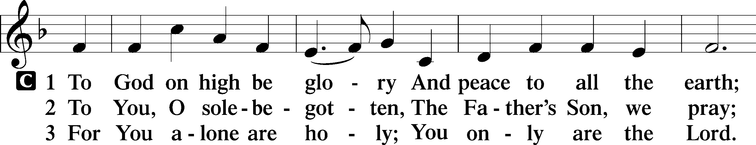

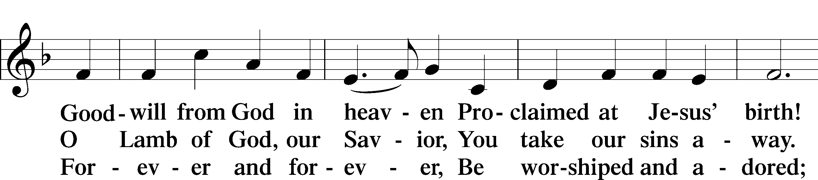

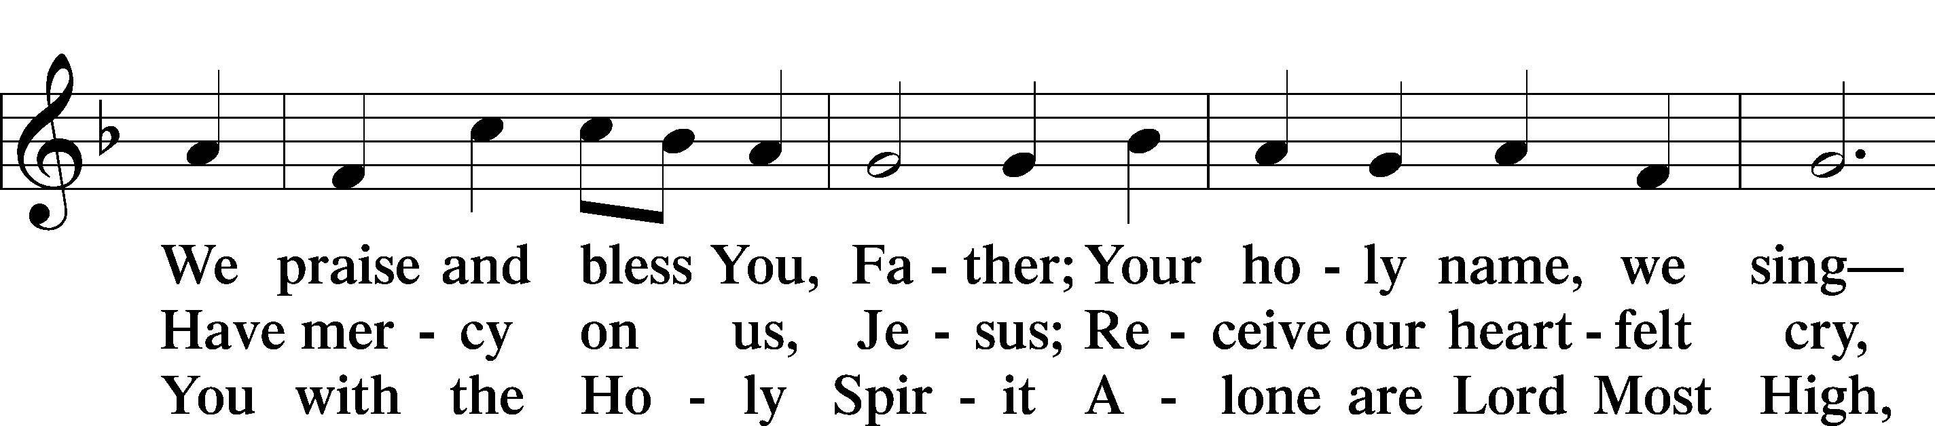

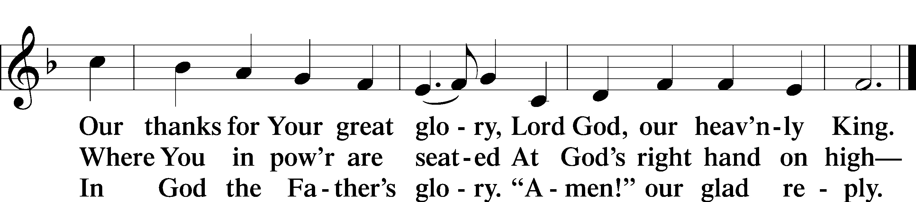

SALUTATION
The Lord be with you.
And also with you.

PRAYER OF THE DAY
Let us pray. Risen and ascended Lord, You now pray for us at the throne of the Father. Keep all those whom You love in Your name, O Lord, that they may be one even as You and the Father are one; for You live and reign with the Father and the Holy Spirit, one God, now and forever.
Amen.

FIRST READING Acts 1:12-26
¹² Then they returned to Jerusalem from the mount called Olivet, which is near Jerusalem, a Sabbath day's journey away. ¹³ And when they had entered, they went up to the upper room, where they were staying, Peter and John and James and Andrew, Philip and Thomas, Bartholomew and Matthew, James the son of Alphaeus and Simon the Zealot and Judas the son of James. ¹⁴ All these with one accord were devoting themselves to prayer, together with the women and Mary the mother of Jesus, and his brothers.
¹⁵ In those days Peter stood up among the brothers (the company of persons was in all about 120) and said, ¹⁶ “Brothers, the Scripture had to be fulfilled, which the Holy Spirit spoke beforehand by the mouth of David concerning Judas, who became a guide to those who arrested Jesus. ¹⁷ For he was numbered among us and was allotted his share in this ministry.” ¹⁸ (Now this man acquired a field with the reward of his wickedness, and falling headlong he burst open in the middle and all his bowels gushed out. ¹⁹ And it became known to all the inhabitants of Jerusalem, so that the field was called in their own language Akeldama, that is, Field of Blood.) ²⁰ “For it is written in the Book of Psalms, “‘May his camp become desolate, and let there be no one to dwell in it’; and “‘Let another take his office.’
²¹ So one of the men who have accompanied us during all the time that the Lord Jesus went in and out among us, ²² beginning from the baptism of John until the day when he was taken up from us—one of these men must become with us a witness to his resurrection.” ²³ And they put forward two, Joseph called Barsabbas, who was also called Justus, and Matthias. ²⁴ And they prayed and said, “You, Lord, who know the hearts of all, show which one of these two you have chosen ²⁵ to take the place in this ministry and apostleship from which Judas turned aside to go to his own place.” ²⁶ And they cast lots for them, and the lot fell on Matthias, and he was numbered with the eleven apostles.

This is the Word of the Lord. Thanks be to God.

ANTHEM (8:00 a.m.) “Simple Song” – Berstein/Soloist - Renee Piel

EPISTLE 1 John 5:9-15
⁹ If we receive the testimony of men, the testimony of God is greater, for this is the testimony of God that he has borne concerning his Son. ¹⁰ Whoever believes in the Son of God has the testimony in himself. Whoever does not believe God has made him a liar, because he has not believed in the testimony that God has borne concerning his Son. ¹¹ And this is the testimony, that God gave us eternal life, and this life is in his Son. ¹² Whoever has the Son has life; whoever does not have the Son of God does not have life.
¹³ I write these things to you who believe in the name of the Son of God, that you may know that you have eternal life. ¹⁴ And this is the confidence that we have toward him, that if we ask anything according to his will he hears us. ¹⁵ And if we know that he hears us in whatever we ask, we know that we have the requests that we have asked of him.

This is the Word of the Lord. Thanks be to God.

HOLY GOSPEL John 17:11b-19
The Holy Gospel according to St. John, the seventeenth chapter.
Glory to You, O Lord.

Holy Father, keep them in your name, which you have given me, that they may be one, even as we are one. ¹² While I was with them, I kept them in your name, which you have given me. I have guarded them, and not one of them has been lost except the son of destruction, that the Scripture might be fulfilled. ¹³ But now I am coming to you, and these things I speak in the world, that they may have my joy fulfilled in themselves. ¹⁴ I have given them your word, and the world has hated them because they are not of the world, just as I am not of the world. ¹⁵ I do not ask that you take them out of the world, but that you keep them from the evil one. ¹⁶ They are not of the world, just as I am not of the world. ¹⁷ Sanctify them in the truth; your word is truth. ¹⁸ As you sent me into the world, so I have sent them into the world. ¹⁹ And for their sake I consecrate myself, that they also may be sanctified in truth.

This is the Gospel of the Lord. Praise to You, O Christ.

NICENE CREED, p. 206
I believe in one God, the Father Almighty, maker of heaven and earth and of all things visible and invisible.
And in one Lord Jesus Christ, the only-begotten Son of God, begotten of his Father before all worlds, God of God, Light of Light, very God of very God, begotten, not made, being of one substance with the Father, by whom all things were made; who for us men and for our salvation came down from heaven and was incarnate by the Holy Spirit of the virgin Mary and was made man; and was crucified also for us under Pontius Pilate. He suffered and was buried. And the third day he rose again according to the Scriptures and ascended into heaven and sits at the right hand of the Father. And he will come again with glory to judge both the living and the dead, whose kingdom will have no end.
And I believe in the Holy Spirit, the Lord and giver of life, who proceeds from the Father and the Son, who with the Father and the Son together is worshiped and glorified, who spoke by the prophets. And I believe in one holy Christian and apostolic Church, I acknowledge one Baptism for the remission of sins, and I look for the resurrection of the dead and the life of the world to come. Amen.

OFFERING PRAYER

SERMON “Listening In Like a Fly on the Wall”
John 17:11b-19 -- Pastor Nate Ruback

SERMON HYMN “Son of God, Eternal Savior,” No. 842
1 Son of God, eternal Savior, Source of life and truth and grace,
Word made flesh, whose birth among us Hallows all our human race,
You our Head, who, throned in glory, For Your own will ever plead:
Fill us with Your love and pity, Heal our wrongs, and help our need.

2 As You, Lord, have lived for others, So may we for others live.
Freely have Your gifts been granted; Freely may Your servants give.
Yours the gold and Yours the silver, Yours the wealth of land and sea;
We but stewards of Your bounty Held in solemn trust will be.

3 Come, O Christ, and reign among us, King of love and Prince of Peace;
Hush the storm of strife and passion, Bid its cruel discords cease.
By Your patient years of toiling, By Your silent hours of pain,
Quench our fevered thirst of pleasure, Stem our selfish greed of gain.

4 Son of God, eternal Savior, Source of life and truth and grace,
Word made flesh, whose birth among us Hallows all our human race:
By Your praying, by Your willing That Your people should be one,
Grant, O grant our hope’s fruition: Here on earth Your will be done.

COMMISSIONING AND INSTALLATION of Mrs. Emmi Forbes (8:00 a.m.)

PRAYER OF THE CHURCH
With all our heart, soul, mind, and strength, let us lift up our prayers before the Lord, saying, Lord, in Your mercy,
Hear our prayer.

Let us pray for the whole Church that we may never take our calling in this world for granted, but to live humbled by God’s making us into His chosen people. Lord, in Your mercy,
Hear our prayer.

Let us pray for those who lead or teach us, not so we can let them do all the ministry for us, but to take seriously in each of our callings that God has chosen us to be a royal priesthood. Lord, in Your mercy,
Hear our prayer.

Let us pray for this and every nation where people are called upon to give a reason for the hope that is within them, doing this with gentleness and respect as members of the Lord’s holy nation that knows no boundaries. Lord, in Your mercy,
Hear our prayer.

Let us pray for us to see Your calling every day in our own lives as Your Spirit enables us to proclaim the excellencies of Him who called us out of darkness into His marvelous light. Lord, in Your mercy,
Hear our prayer.

Let us pray to rejoice with those who rejoice today, that their joy and ours may be full. Lord, in Your mercy,
Hear our prayer.

Let us pray for the sick and suffering, to receive Your promise of powerful and effective healing as well as Your peace. Lord, in Your mercy,
Hear our prayer.

Blessings and honor and power and glory be to our God forever and ever.
Amen.

LORD’S PRAYER, p. 209
Our Father, who art in heaven, hallowed be thy name, thy kingdom come, thy will be done on earth as it is in heaven. Give us this day our daily bread; and forgive us our trespasses, as we forgive those who trespass against us; and lead us not into temptation, but deliver us from evil. For thine is the kingdom and the power and the glory forever and ever. Amen.

WORDS OF OUR LORD, p. 162
Our Lord Jesus Christ, on the night when He was betrayed, took bread, and when He had given thanks, He broke it and gave it to the disciples and said: “Take, eat; this is My + body, which is given for you. This do in remembrance of Me.”
In the same way also He took the cup after supper, and when He had given thanks, He gave it to them, saying: “Drink of it, all of you; this cup is the new testament in My + blood, which is shed for you for the forgiveness of sins. This do, as often as you drink it, in remembrance of Me.”

PAX DOMINI, p. 210
The peace of the Lord be with you always.
Amen.

DISTRIBUTION
Distribution Hymns:
“Lord, Thee I Love with All My Heart,” No. 708 (with organ meditations between each stanza)
1 Lord, Thee I love with all my heart; I pray Thee, ne’er from me depart,
With tender mercy cheer me. Earth has no pleasure I would share.
Yea, heav’n itself were void and bare If Thou, Lord, wert not near me.
And should my heart for sorrow break, My trust in Thee can nothing shake.
Thou art the portion I have sought; Thy precious blood my soul has bought.
Lord Jesus Christ, my God and Lord, my God and Lord,
Forsake me not! I trust Thy Word.

2 Yea, Lord, ’twas Thy rich bounty gave My body, soul, and all I have
In this poor life of labor. Lord, grant that I in ev’ry place
May glorify Thy lavish grace And help and serve my neighbor.
Let no false doctrine me beguile; Let Satan not my soul defile.
Give strength and patience unto me To bear my cross and follow Thee.
Lord Jesus Christ, my God and Lord, my God and Lord,
In death Thy comfort still afford.

3 Lord, let at last Thine angels come, To Abr’ham’s bosom bear me home,
That I may die unfearing; And in its narrow chamber keep
My body safe in peaceful sleep Until Thy reappearing.
And then from death awaken me, That these mine eyes with joy may see,
O Son of God, Thy glorious face, My Savior and my fount of grace.
Lord Jesus Christ, my prayer attend, my prayer attend,
And I will praise Thee without end.

“Sent Forth by God’s Blessing,” No. 643
1 Sent forth by God’s blessing, Our true faith confessing,
The people of God from His dwelling take leave.
The Supper is ended. O now be extended
The fruits of this service in all who believe.
The seed of His teaching, Receptive souls reaching,
Shall blossom in action for God and for all.
His grace did invite us, His love shall unite us
To work for God’s kingdom and answer His call.

2 With praise and thanksgiving To God ever-living,
The tasks of our ev’ryday life we will face.
Our faith ever sharing, In love ever caring,
Embracing His children of each tribe and race.
With Your feast You feed us, With Your light now lead us;
Unite us as one in this life that we share.
Then may all the living With praise and thanksgiving
Give honor to Christ and His name that we bear.
Text: © 1964 World Library Publications. Used by permission: LSB Hymn License no. 110003490

DISMISSAL BLESSING, p. 210
The body and blood of our Lord Jesus Christ strengthen and preserve you in body and soul to life everlasting. Depart + in peace.
Amen.

POST-COMMUNION COLLECT, p. 212
We give thanks to You, almighty God, that You have refreshed us through this salutary gift, and we implore You that of Your mercy You would strengthen us through the same in faith toward You and fervent love toward one another; through Jesus Christ, Your Son, our Lord, who lives and reigns with You and the Holy Spirit, one God, now and forever.
Amen.

BENEDICTION
The Lord bless you and keep you.
The Lord make His face shine on you and be gracious to you.
The Lord look upon you with favor and + give you peace.
Amen.
CLOSING HYMN “The Church’s One foundation,” No. 644
1 The Church’s one foundation Is Jesus Christ, her Lord;
She is His new creation By water and the Word.
From heav’n He came and sought her To be His holy bride;
With His own blood He bought her, And for her life He died.

2 Elect from ev’ry nation, Yet one o’er all the earth;
Her charter of salvation: One Lord, one faith, one birth.
One holy name she blesses, Partakes one holy food,
And to one hope she presses With ev’ry grace endued.

3 Though with a scornful wonder The world sees her oppressed,
By schisms rent asunder, By heresies distressed,
Yet saints their watch are keeping; Their cry goes up, “How long?”
And soon the night of weeping Shall be the morn of song.

4 Through toil and tribulation And tumult of her war
She waits the consummation Of peace forevermore
Till with the vision glorious Her longing eyes are blest,
And the great Church victorious Shall be the Church at rest.

5 Yet she on earth has union With God, the Three in One,
And mystic sweet communion With those whose rest is won.
O blessèd heav’nly chorus! Lord, save us by Your grace
That we, like saints before us, May see You face to face.

POSTLUDE

Grace is for all!

