GRACE LUTHERAN CHAPEL
Grace Chapel exists to make and keep disciples for Jesus Christ.

Twenty-fourth Sunday after Pentecost
Saturday, November 14, 2020 - 4:00 p.m.
Sunday, November 15, 2020 - 8:00 a.m.

Welcome to Grace Lutheran Chapel and to our worship with Holy Communion. As Lutheran Christians we believe and confess that Christ’s Body and Blood are present in the bread and wine of Holy Communion. This meal benefits those who acknowledge and confess their sin and trust in Christ alone for their salvation. Where Christ’s true body and blood are present, so also is the forgiveness of sins and eternal life. Baptized and instructed Christians who share in this belief are welcome to this meal of our Lord’s grace and forgiveness.

WELCOME/ANNOUNCEMENTS/GREETING

OPENING HYMN “We Praise You and Acknowledge You, O God” No. 941
(8:00 a.m.) –Choir (v. 2) and Congregation
1 We praise You and acknowledge You, O God, to be the Lord,
The Father everlasting, by all the earth adored.
To You all angel powers cry aloud, the heavens sing,
The cherubim and seraphim their praises to You bring:
“O holy, holy, holy Lord God of Sabaoth;
Your majesty and glory fill the heavens and the earth!”

2 The band of the apostles in glory sing Your praise;
The fellowship of prophets their deathless voices raise.
The martyrs of Your kingdom, a great and noble throng,
Sing with the holy Church throughout all the world this song:
“O all-majestic Father, Your true and only Son,
And Holy Spirit, Comforter—forever Three in One!”

3 You, Christ, are King of glory, the everlasting Son,
Yet You, with boundless love, sought to rescue ev’ryone:
You laid aside Your glory, were born of virgin’s womb,
Were crucified for us and were placed into a tomb;
Then by Your resurrection You won for us reprieve—
You opened heaven’s kingdom to all who would believe.

4 You sit in splendid glory, enthroned at God’s right hand,
Upholding earth and heaven by forces You command.
We know that You will come as our Judge that final day,
So help Your servants You have redeemed by blood, we pray;
May we with saints be numbered where praises never end,
In glory everlasting. Amen, O Lord, amen!
Text: © 1999 Stephen P. Starke, admin. Concordia Publishing House.
Used by permission: LSB Hymn License no. 110003490

LITURGY - Divine Service 4, p. 203 in Lutheran Service Book (please stand)

INVOCATION
In the name of the Father and of the + Son and of the Holy Spirit.
Amen.

EXHORTATION
Our help is in the name of the Lord,
who made heaven and earth.

If You, O Lord, kept a record of sins, O Lord, who could stand?
But with You there is forgiveness; therefore You are feared.

Since we are gathered to hear God’s Word, call upon Him in prayer and praise, and receive the body and blood of our Lord Jesus Christ in the fellowship of this altar, let us first consider our unworthiness and confess before God and one another that we have sinned in thought, word, and deed, and that we cannot free ourselves from our sinful condition. Together as His people let us take refuge in the infinite mercy of God, our heavenly Father, seeking His grace for the sake of Christ, and saying: God, be merciful to me, a sinner.

CONFESSION OF SINS
Almighty God, have mercy upon us, forgive us our sins, and lead us to everlasting life. Amen.

ABSOLUTION
Almighty God in His mercy has given His Son to die for you and for His sake forgives you all your sins. As a called and ordained servant of Christ, and by His authority, I therefore forgive you all your sins in the name of the Father and of the + Son and of the Holy Spirit.
Amen.

HYMN OF PRAISE - “Gloria In Excelsis” p. 204
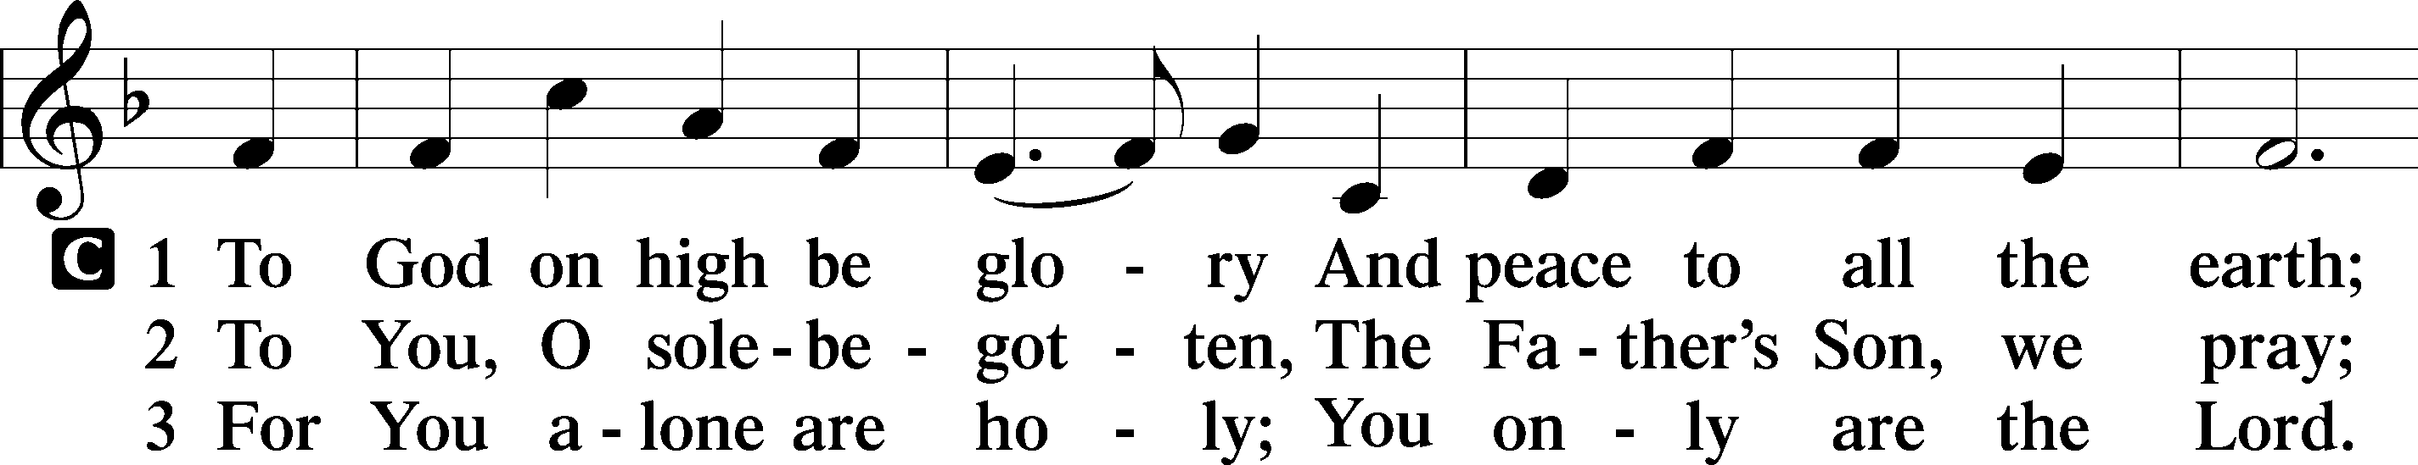

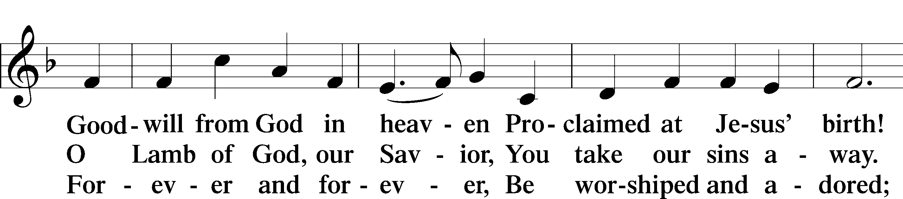

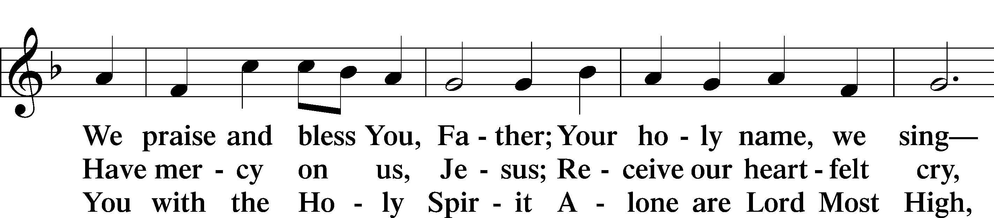

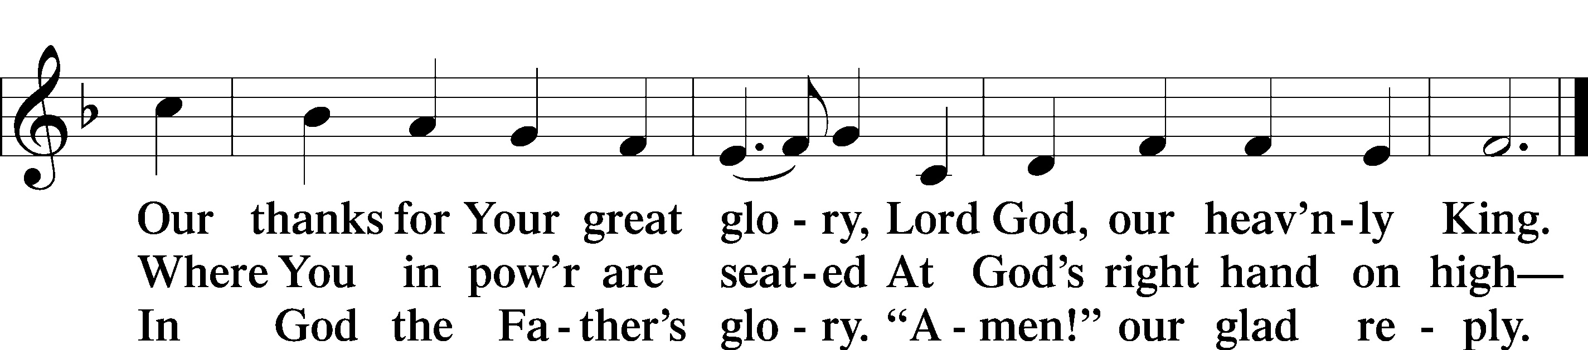

SALUTATION
The Lord be with you.
And also with you.

PRAYER OF THE DAY
Let us pray. Heavenly Father, You are our good and faithful Master. Thank You for the abundance of blessings You have poured into our lives. Strengthen us by Your mighty power, that we might serve You well and faithfully; through Jesus Christ, Your Son, our Lord, who lives and reigns with You and the Holy Spirit, one God, now and forever.
Amen.

OLD TESTAMENT READING Zephaniah 1:7-16
⁷ Be silent before the Lord God! For the day of the Lord is near; the Lord has prepared a sacrifice and consecrated his guests. ⁸ And on the day of the Lord's sacrifice—“I will punish the officials and the king's sons and all who array themselves in foreign attire. ⁹ On that day I will punish everyone who leaps over the threshold, and those who fill their master's house with violence and fraud. ¹⁰ “On that day,” declares the Lord, “a cry will be heard from the Fish Gate, a wail from the Second Quarter, a loud crash from the hills. ¹¹ Wail, O inhabitants of the Mortar! For all the traders are no more; all who weigh out silver are cut off. ¹² At that time I will search Jerusalem with lamps, and I will punish the men who are complacent, those who say in their hearts, ‘The Lord will not do good, nor will he do ill.’
¹³ Their goods shall be plundered, and their houses laid waste. Though they build houses, they shall not inhabit them; though they plant vineyards, they shall not drink wine from them.” ¹⁴ The great day of the Lord is near, near and hastening fast; the sound of the day of the Lord is bitter; the mighty man cries aloud there. ¹⁵ A day of wrath is that day, a day of distress and anguish, a day of ruin and devastation, a day of darkness and gloom, a day of clouds and thick darkness, ¹⁶ a day of trumpet blast and battle cry against the fortified cities and against the lofty battlements.

This is the Word of the Lord. Thanks be to God.

EPISTLE 1 Thessalonians 5:1-11
Now concerning the times and the seasons, brothers, you have no need to have anything written to you. ² For you yourselves are fully aware that the day of the Lord will come like a thief in the night. ³ While people are saying, “There is peace and security,” then sudden destruction will come upon them as labor pains come upon a pregnant woman, and they will not escape. ⁴ But you are not in darkness, brothers, for that day to surprise you like a thief. ⁵ For you are all children of light, children of the day. We are not of the night or of the darkness. ⁶ So then let us not sleep, as others do, but let us keep awake and be sober. ⁷ For those who sleep, sleep at night, and those who get drunk, are drunk at night. ⁸ But since we belong to the day, let us be sober, having put on the breastplate of faith and love, and for a helmet the hope of salvation. ⁹ For God has not destined us for wrath, but to obtain salvation through our Lord Jesus Christ, ¹⁰ who died for us so that whether we are awake or asleep we might live with him. ¹¹ Therefore encourage one another and build one another up, just as you are doing.

This is the Word of the Lord. Thanks be to God.

HOLY GOSPEL Matthew 25:14-30
The Holy Gospel according to St. Matthew, the twenty-fifth chapter.
Glory to You, O Lord.

¹⁴ “For it will be like a man going on a journey, who called his servants and entrusted to them his property. ¹⁵ To one he gave five talents, to another two, to another one, to each according to his ability. Then he went away. ¹⁶ He who had received the five talents went at once and traded with them, and he made five talents more. ¹⁷ So also he who had the two talents made two talents more. ¹⁸ But he who had received the one talent went and dug in the ground and hid his master's money. ¹⁹ Now after a long time the master of those servants came and settled accounts with them. ²⁰ And he who had received the five talents came forward, bringing five talents more, saying, ‘Master, you delivered to me five talents; here, I have made five talents more.’ ²¹ His master said to him, ‘Well done, good and faithful servant. You have been faithful over a little; I will set you over much. Enter into the joy of your master.’ ²² And he also who had the two talents came forward, saying, ‘Master, you delivered to me two talents; here, I have made two talents more.’ ²³ His master said to him, ‘Well done, good and faithful servant. You have been faithful over a little; I will set you over much. Enter into the joy of your master.’ ²⁴ He also who had received the one talent came forward, saying, ‘Master, I knew you to be a hard man, reaping where you did not sow, and gathering where you scattered no seed, ²⁵ so I was afraid, and I went and hid your talent in the ground. Here, you have what is yours.’ ²⁶ But his master answered him, ‘You wicked and slothful servant! You knew that I reap where I have not sown and gather where I scattered no seed? ²⁷ Then you ought to have invested my money with the bankers, and at my coming I should have received what was my own with interest. ²⁸ So take the talent from him and give it to him who has the ten talents. ²⁹ For to everyone who has will more be given, and he will have an abundance. But from the one who has not, even what he has will be taken away. ³⁰ And cast the worthless servant into the outer darkness. In that place there will be weeping and gnashing of teeth.’

This is the Gospel of the Lord. Praise to You, O Christ.

NICENE CREED, p. 206
I believe in one God, the Father Almighty, maker of heaven and earth and of all things visible and invisible.
And in one Lord Jesus Christ, the only-begotten Son of God, begotten of his Father before all worlds, God of God, Light of Light, very God of very God, begotten, not made, being of one substance with the Father, by whom all things were made; who for us men and for our salvation came down from heaven and was incarnate by the Holy Spirit of the virgin Mary and was made man; and was crucified also for us under Pontius Pilate. He suffered and was buried. And the third day he rose again according to the Scriptures and ascended into heaven and sits at the right hand of the Father. And he will come again with glory to judge both the living and the dead, whose kingdom will have no end.
And I believe in the Holy Spirit, the Lord and giver of life, who proceeds from the Father and the Son, who with the Father and the Son together is worshiped and glorified, who spoke by the prophets. And I believe in one holy Christian and apostolic Church, I acknowledge one Baptism for the remission of sins, and I look for the resurrection of the dead and the life of the world to come. Amen.

OFFERING PRAYER

SERMON “Judgment Day and the Poplar Tree”
Zephaniah 1:7-16 – Pastor Eric Stacy

SERMON HYMN "Saints, See the Cloud of Witnesses” No. 667
- Saints, see the cloud of witnesses surround us;
Their lives of faith encourage and astound us.
Hear how the Master praised their faith so fervent: “Well done, My servant!”
2 These saints of old received God’s commendation;
They lived as pilgrim-heirs of His salvation.
Through faith they conquered flame and sword and gallows, God’s name to hallow.

3 They call to us, “Your timid footsteps lengthen;
Throw off sin’s weight, your halting weakness strengthen.
We kept the faith, we shed our blood, were martyred; Our lives we bartered.”

4 Come, let us fix our sight on Christ who suffered,
He faced the cross, His sinless life He offered;
He scorned the shame, He died, our death enduring, Our hope securing.

5 Lord, give us faith to walk where You are sending,
On paths unmarked, eyes blind as to their ending;
Not knowing where we go, but that You lead us—With grace precede us.

6 You, Jesus, You alone deserve all glory!
Our lives unfold, embraced within Your story;
Past, present, future—You, the same forever—You fail us never!
Text: © 1997 Stephen P. Starke, admin. Concordia Publishing House.
Used by permission: LSB Hymn License no. 110003490

PRAYER OF THE CHURCH
Dear heavenly Father, You have placed us in various vocations for the sake of Your people. Strengthen us when we face challenges and trials that would tempt us to abandon Your Church. Forgive us when we go astray. Bring back all those who have wandered from the faith. Hear our prayer, O Lord.
Give ear to our pleas for mercy.

Lord, raise up good and faithful servants in Your Church, that we work together for the common good and spread the good news of Your kingdom to all nations. Hear our prayer, O Lord.
Give ear to our pleas for mercy.

Lord, raise up good and faithful servants in the governments of the world, that citizens of all nations might be treated with fairness and justice. Hear our prayer, O Lord.
Give ear to our pleas for mercy.

Lord, the day of Jesus’ return is drawing near. Give us patience and faith as we await His return. Embolden us to serve our neighbors and never grow weary of doing good. Hear our prayer, O Lord.
Give ear to our pleas for mercy.
Lord, disease and devastation have infected so much of Your creation, but we know Your healing is always close at hand. Be with all those who suffer now through abuse, illness, and injustice. Heal them according to Your will, and send justice for the oppressed. Hear our prayer, O Lord.
Give ear to our pleas for mercy.

Lord, by the resurrection of Your Son, death has been destroyed. Yet each human being still faces earthly death. We bring before You all those who are mourning the death of loved ones. Comfort them with the hope of the resurrection to eternal life. Hear our prayer, O Lord.
Give ear to our pleas for mercy.

Into Your hands, O Lord, we commend all for whom we pray, trusting in Your mercy; through Jesus Christ, Your Son, our Lord.
Amen.

LORD’S PRAYER, p. 209
Our Father, who art in heaven, hallowed be thy name, thy kingdom come, thy will be done on earth as it is in heaven. Give us this day our daily bread; and forgive us our trespasses, as we forgive those who trespass against us; and lead us not into temptation, but deliver us from evil. For thine is the kingdom and the power and the glory forever and ever. Amen.

WORDS OF OUR LORD, p. 162
Our Lord Jesus Christ, on the night when He was betrayed, took bread, and when He had given thanks, He broke it and gave it to the disciples and said: “Take, eat; this is My + body, which is given for you. This do in remembrance of Me.”
In the same way also He took the cup after supper, and when He had given thanks, He gave it to them, saying: “Drink of it, all of you; this cup is the new testament in My + blood, which is shed for you for the forgiveness of sins. This do, as often as you drink it, in remembrance of Me.”

PAX DOMINI, p. 210
The peace of the Lord be with you always.
Amen.

DISTRIBUTION - Distribution Hymns:
“Come, Thou Long-Expected Jesus,” No. 338 (8:00 a.m. – Choir and Congregation)
1 Come, Thou long-expected Jesus, Born to set Thy people free;
From our fears and sins release us; Let us find our rest in Thee.
Israel’s strength and consolation, Hope of all the earth Thou art,
Dear desire of ev’ry nation, Joy of ev’ry longing heart.
2 Born Thy people to deliver; Born a child and yet a king!
Born to reign in us forever, Now Thy gracious kingdom bring.
By Thine own eternal Spirit Rule in all our hearts alone;
By Thine all-sufficient merit Raise us to Thy glorious throne.

“One Thing’s Needful,” No. 536, vv. 1, 3-5
1 One thing’s needful; Lord, this treasure
Teach me highly to regard.
All else, though it first give pleasure,
Is a yoke that presses hard!
Beneath it the heart is still fretting and striving,
No true, lasting happiness ever deriving.
This one thing is needful; all others are vain—
I count all but loss that I Christ may obtain!

3 Wisdom’s highest, noblest treasure,
Jesus, is revealed in You.
Let me find in You my pleasure,
And my wayward will subdue,
Humility there and simplicity reigning,
In paths of true wisdom my steps ever training.
If I learn from Jesus this knowledge divine,
The blessing of heavenly wisdom is mine.

4 Nothing have I, Christ, to offer,
You alone, my highest good.
Nothing have I, Lord, to proffer
But Your crimson-colored blood.
Your death on the cross has death wholly defeated
And thereby my righteousness fully completed;
Salvation’s white raiments I there did obtain,
And in them in glory with You I shall reign.

5 Therefore You alone, my Savior,
Shall be all in all to me;
Search my heart and my behavior,
Root out all hypocrisy.
Through all my life’s pilgrimage, guard and uphold me,
In loving forgiveness, O Jesus, enfold me.
This one thing is needful; all others are vain—
I count all but loss that I Christ may obtain!

DISMISSAL BLESSING, p. 210
The body and blood of our Lord Jesus Christ strengthen and preserve you in body and soul to life everlasting. Depart + in peace.
Amen.

POST-COMMUNION COLLECT, p. 212
We give thanks to You, almighty God, that You have refreshed us through this salutary gift, and we implore You that of Your mercy You would strengthen us through the same in faith toward You and fervent love toward one another; through Jesus Christ, Your Son, our Lord, who lives and reigns with You and the Holy Spirit, one God, now and forever.
Amen.

BENEDICTION
The Lord bless you and keep you.
The Lord make His face shine on you and be gracious to you.
The Lord look upon you with favor and + give you peace.
Amen.

CLOSING HYMN “Lord, Dismiss Us with Your Blessing,” No. 924
1 Lord, dismiss us with Your blessing, Fill our hearts with joy and peace;
Let us each, Your love possessing, Triumph in redeeming grace.
O refresh us; O refresh us,
Trav’ling through this wilderness.

2 Thanks we give and adoration For Your Gospel’s joyful sound.
May the fruits of Your salvation In our hearts and lives abound.
Ever faithful, ever faithful
To Your truth may we be found.

3 Savior, when Your love shall call us From our struggling pilgrim way,
Let not fear of death appall us, Glad Your summons to obey.
May we ever, may we ever
Reign with You in endless day.

POSTLUDE

Grace is for all!

